Tour ID: 108766  
Tour Name: 8 Day - Iceland Northern Lights Tour

Tour destinations: ['Reykjavik', 'Thingvellir National Park', 'Geysir', 'Dover', 'Gullfoss', 'Seljaland', 'Skogafoss', 'Vik', 'Reynisfjara', 'Reynisdrangar Cliffs', 'Eyjafjallajokull', 'Myrdalsjokull', 'Skaftafell', 'Vatnajokull National Park', 'Jokulsarlon', 'Hofn', 'Djupivogur', 'Egilsstadir', 'Dettifoss', 'Myvatn', 'Hverfjall Volcano', 'Godafoss', 'Akureyri', 'Dalvik', 'Siglufjordur', 'Grábrók Volcano', 'Reykholt']

Tour destinations images:

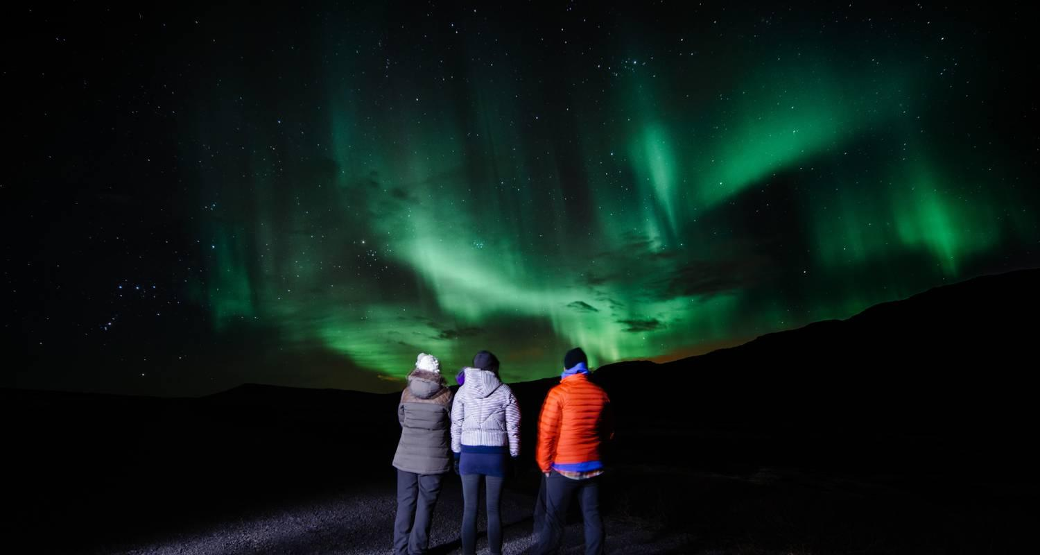

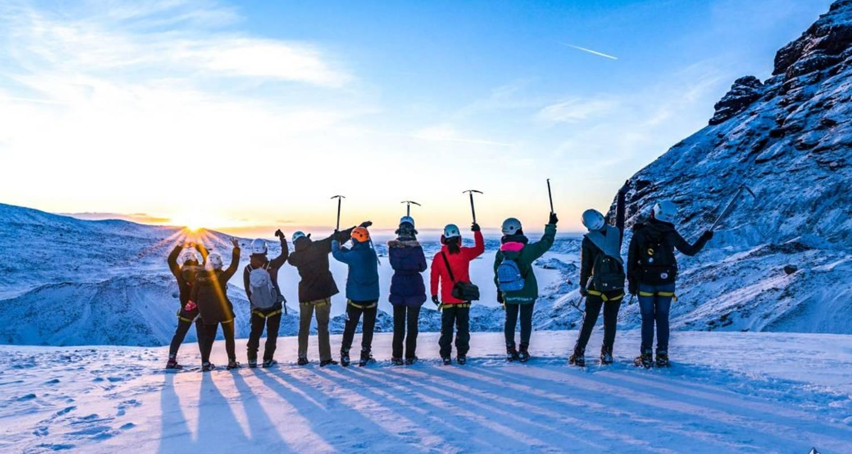

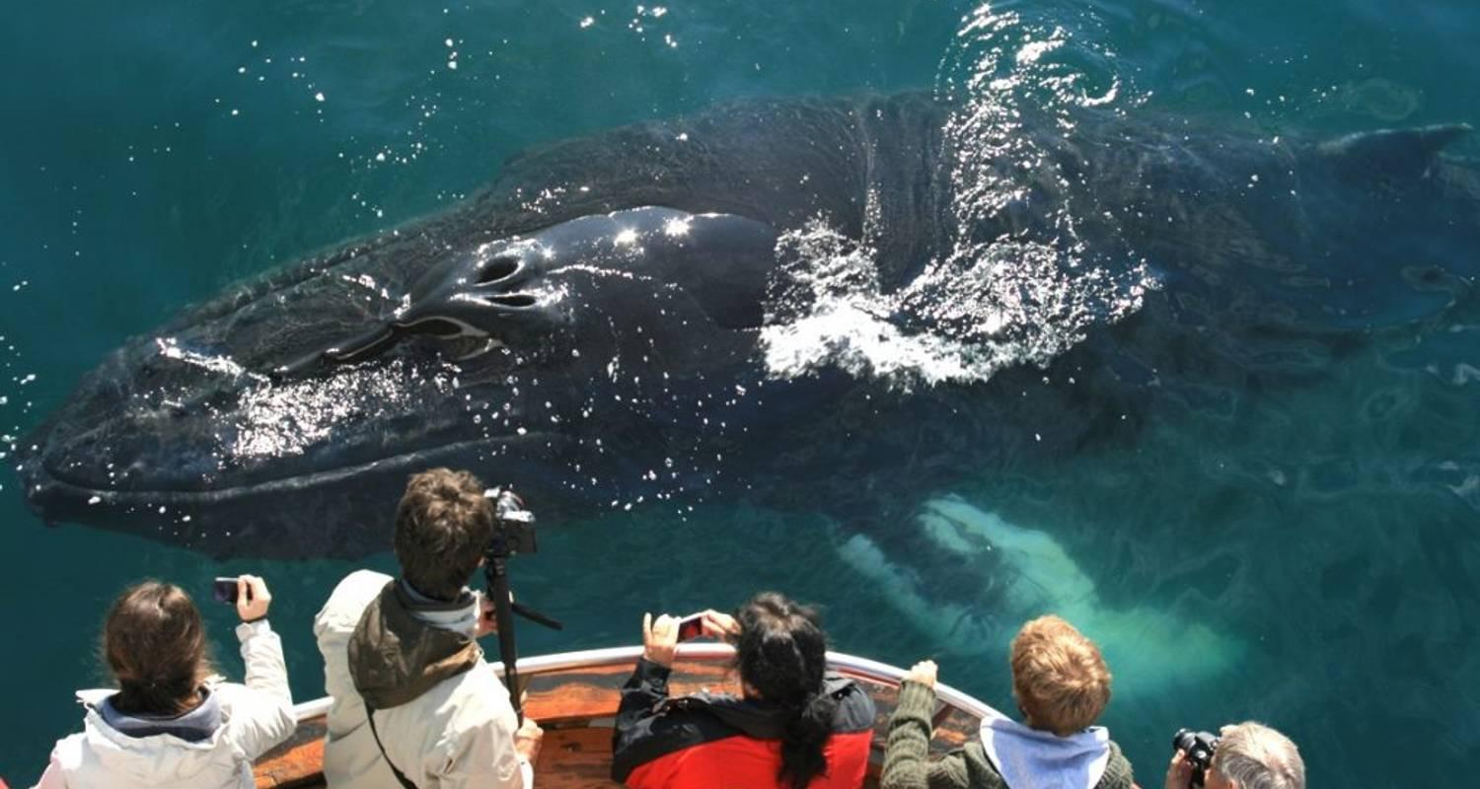

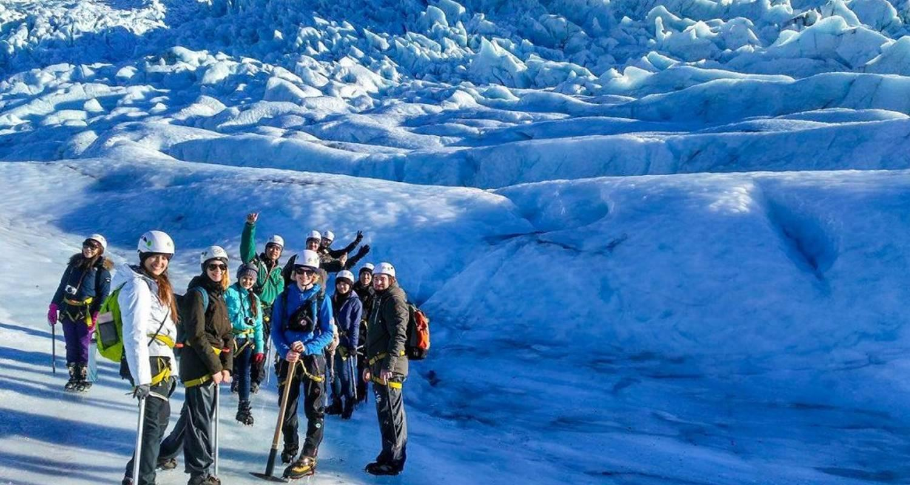

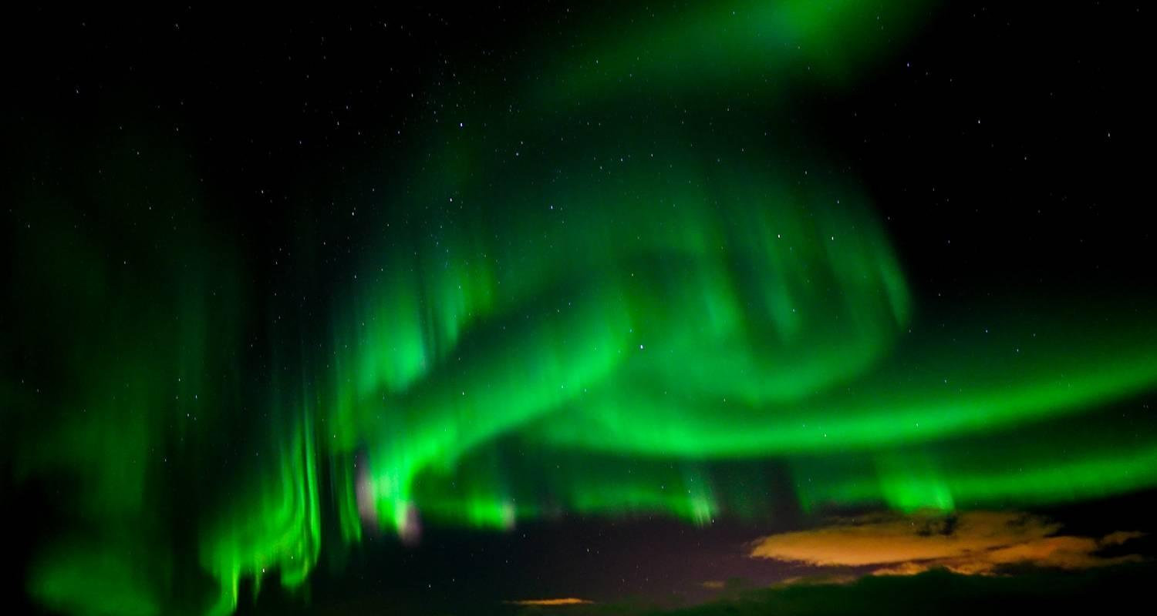

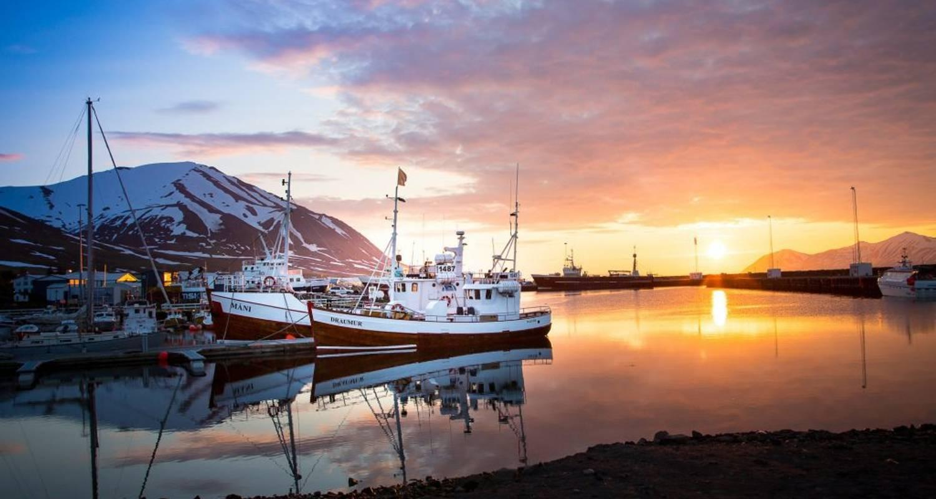

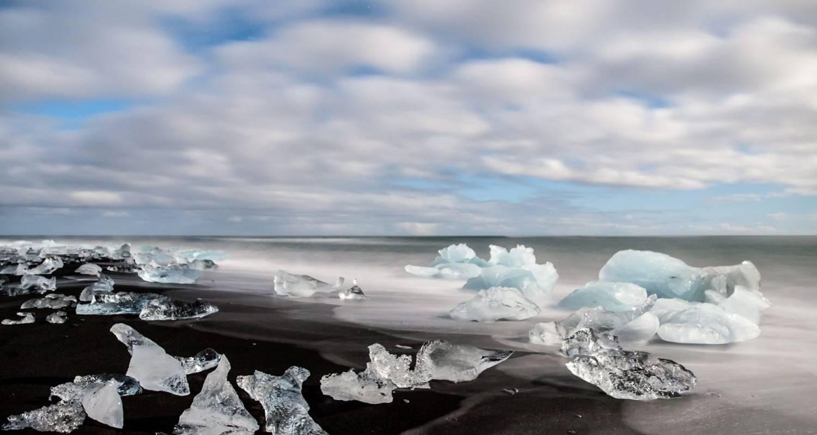

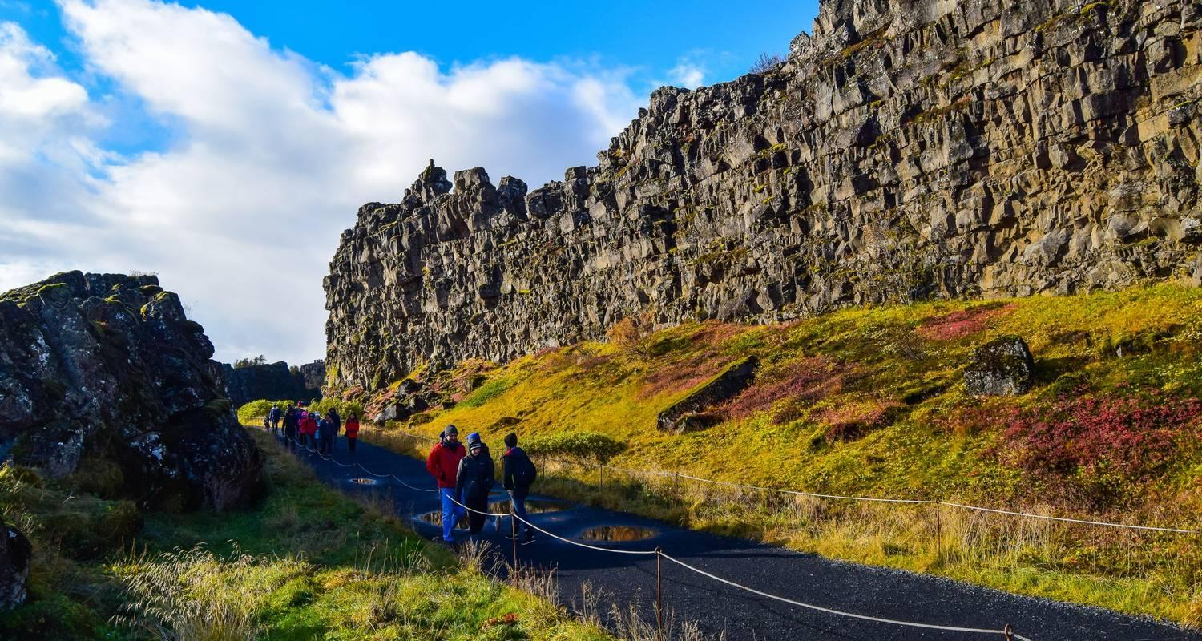

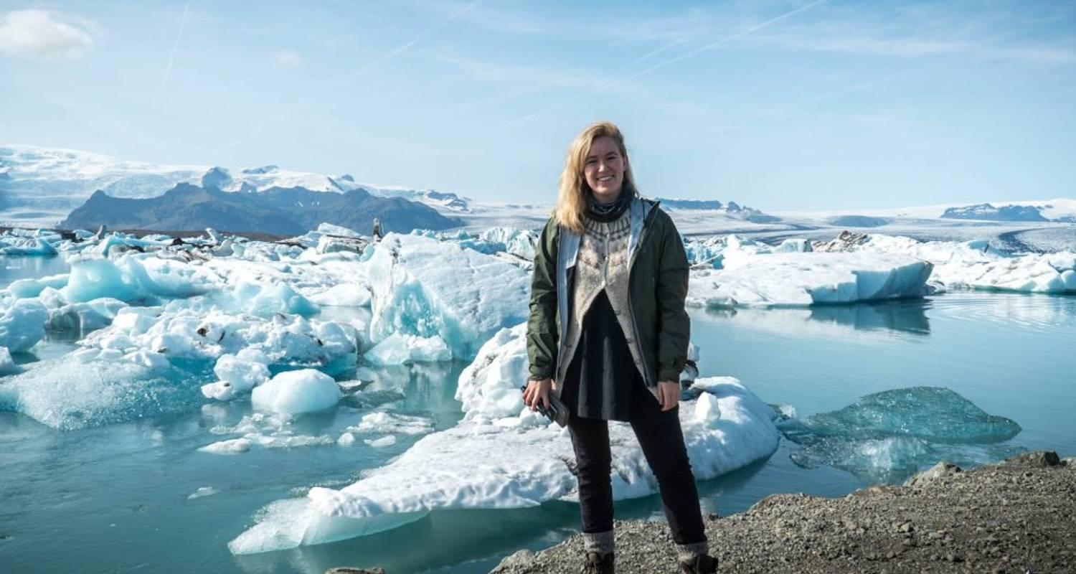

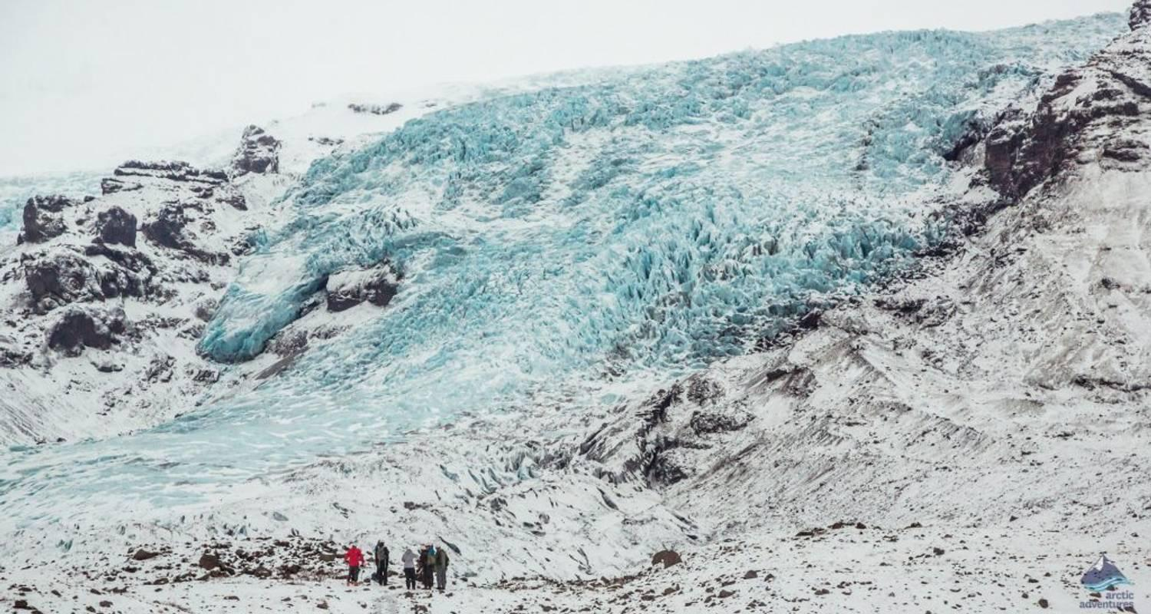

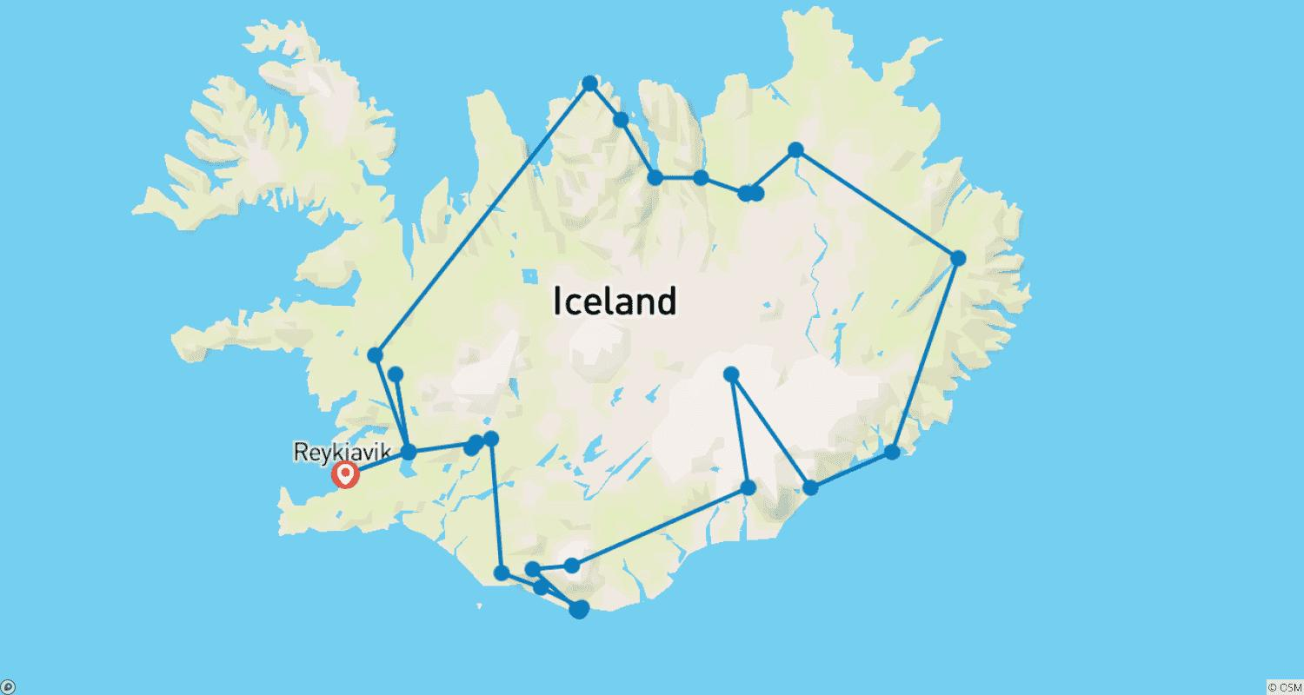

Tour ID: 108771  
Tour Name: 8 Day - Iceland Ring Road Tour

Tour destinations: ['Reykjavik', 'Thingvellir National Park', 'Dover', 'Gullfoss', 'Seljaland', 'Skogafoss', 'Reynisfjara', 'Myrdalsjokull', 'Eyjafjallajokull', 'Skaftafell', 'Vatnajokull National Park', 'Jokulsarlon', 'Djupivogur', 'Egilsstadir', 'Dettifoss', 'Myvatn', 'Mount Namaskard', 'Hverfjall Volcano', 'Godafoss', 'Akureyri', 'Dalvik', 'Siglufjordur', 'Grábrók Volcano', 'Reykholt']

Tour destinations images:

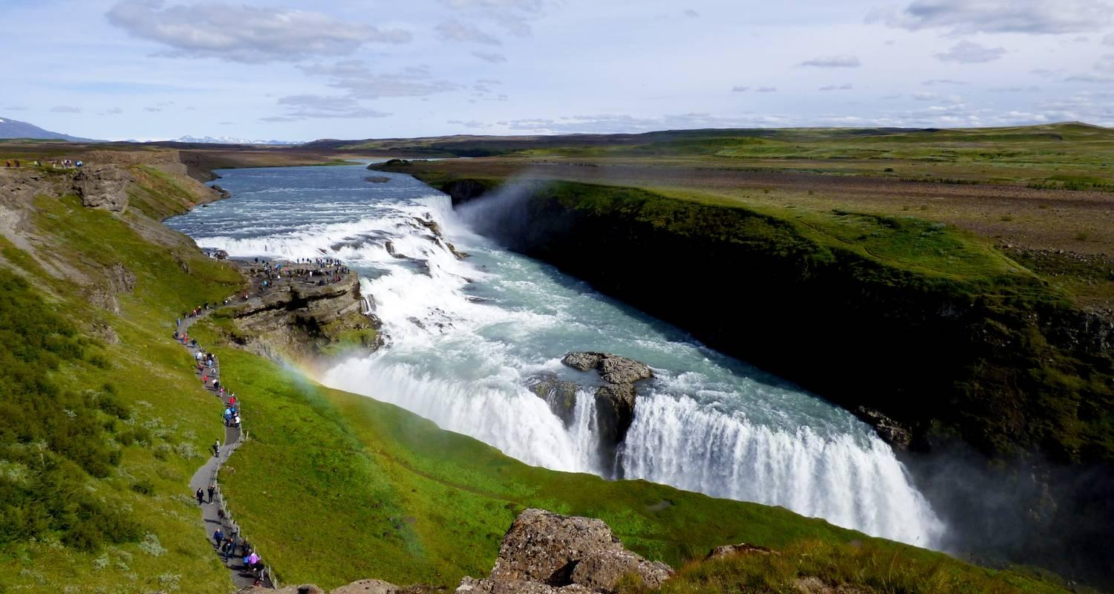

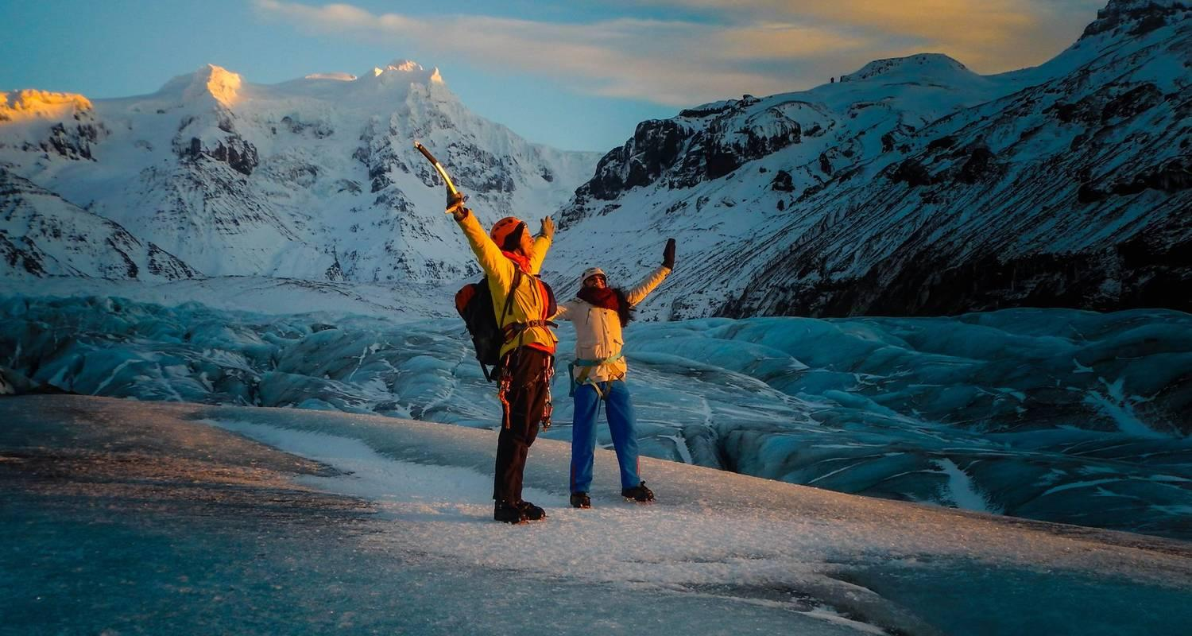

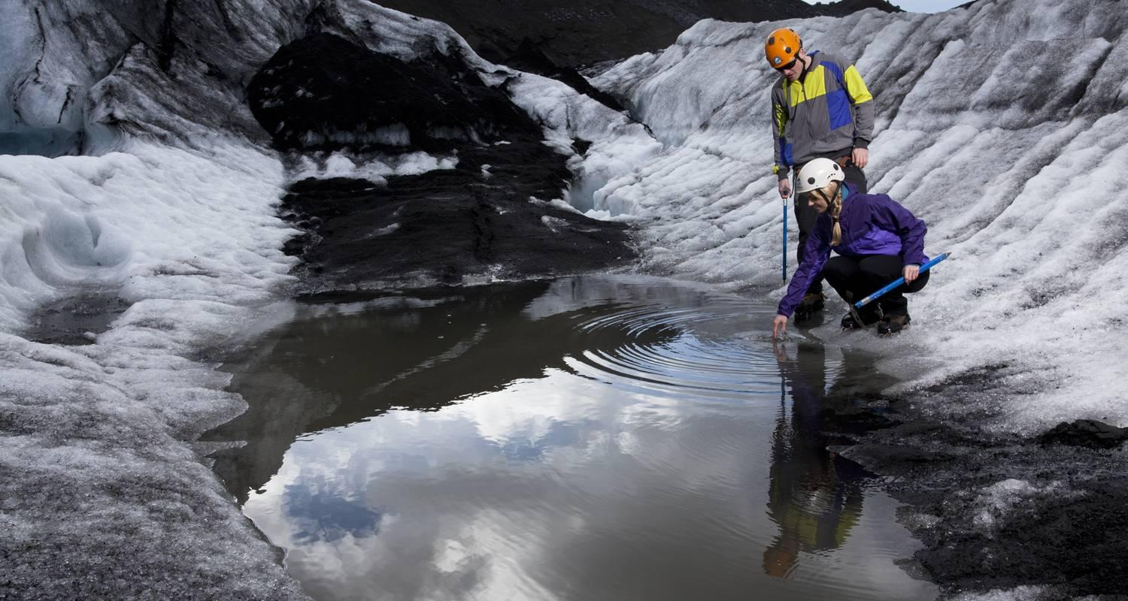

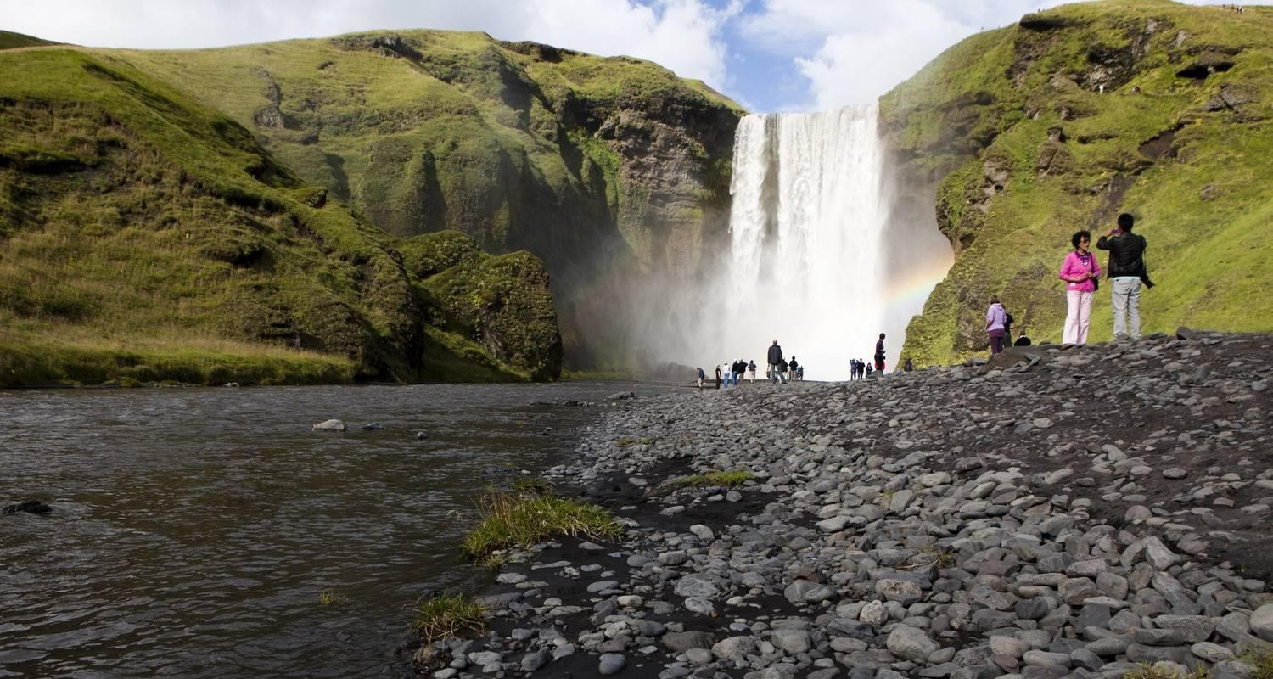

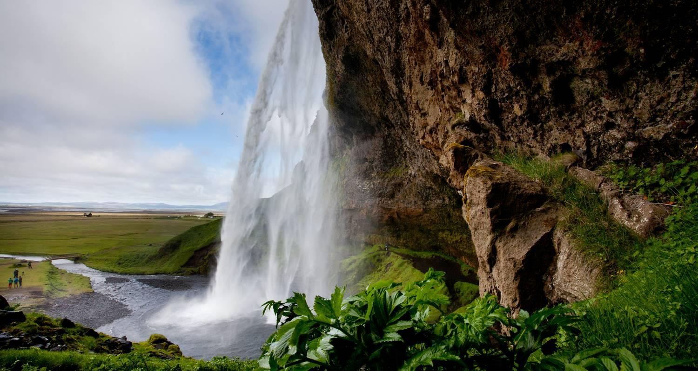

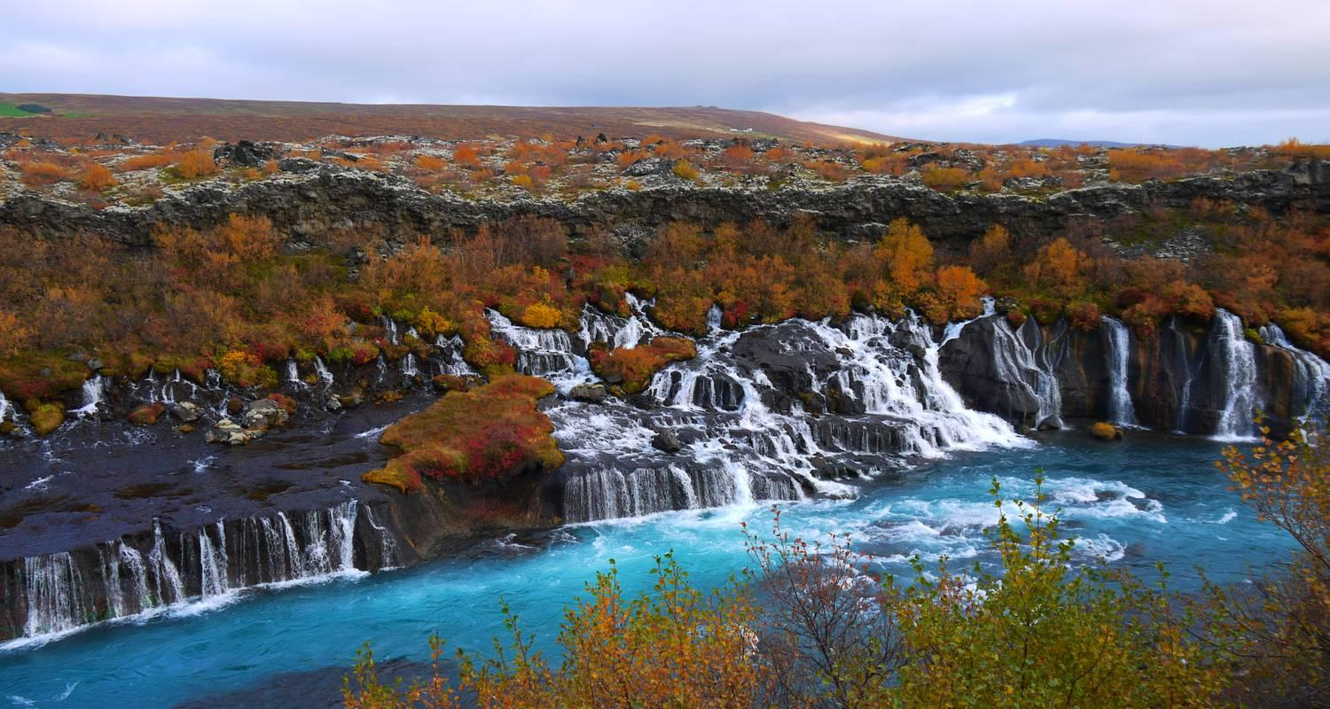

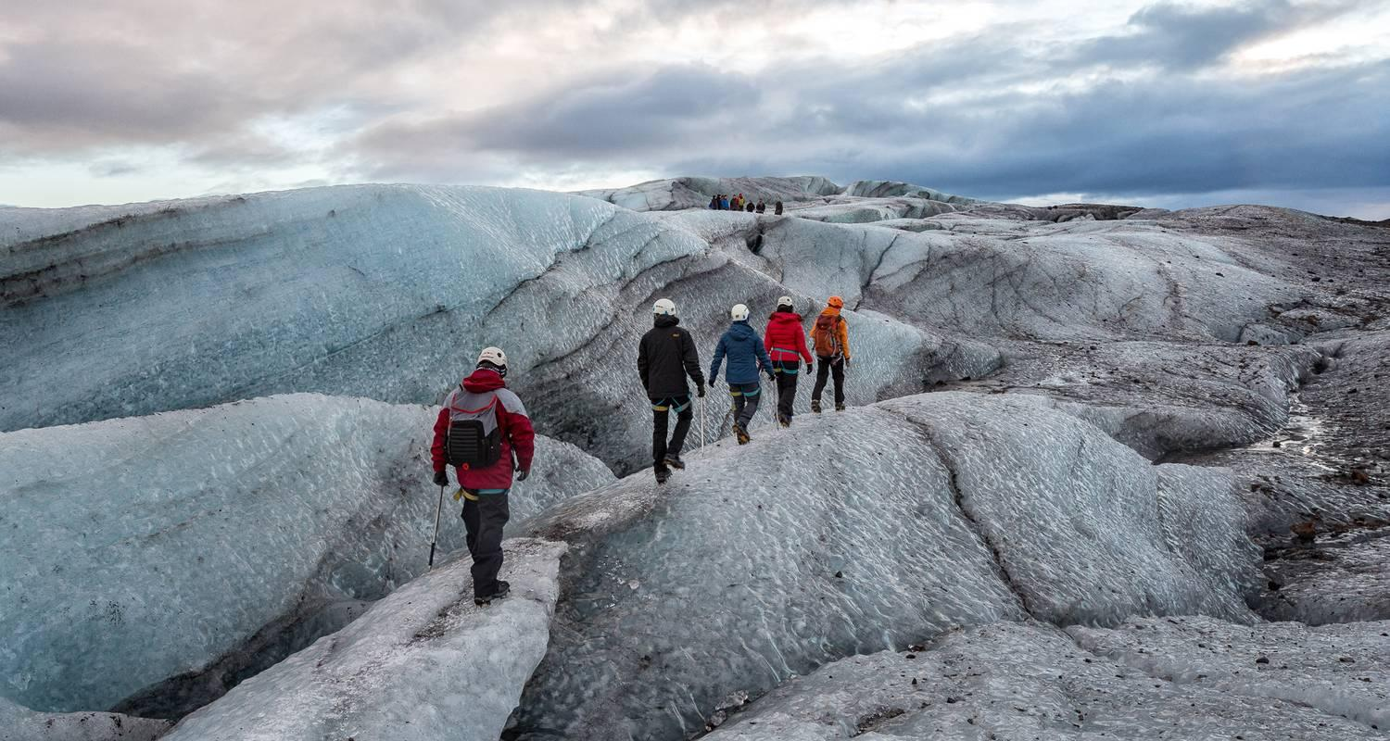

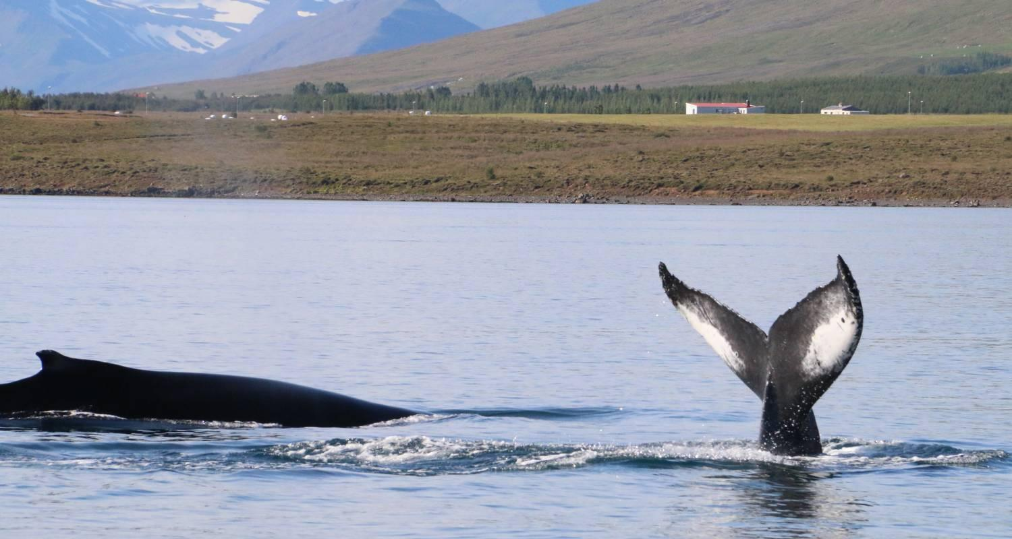

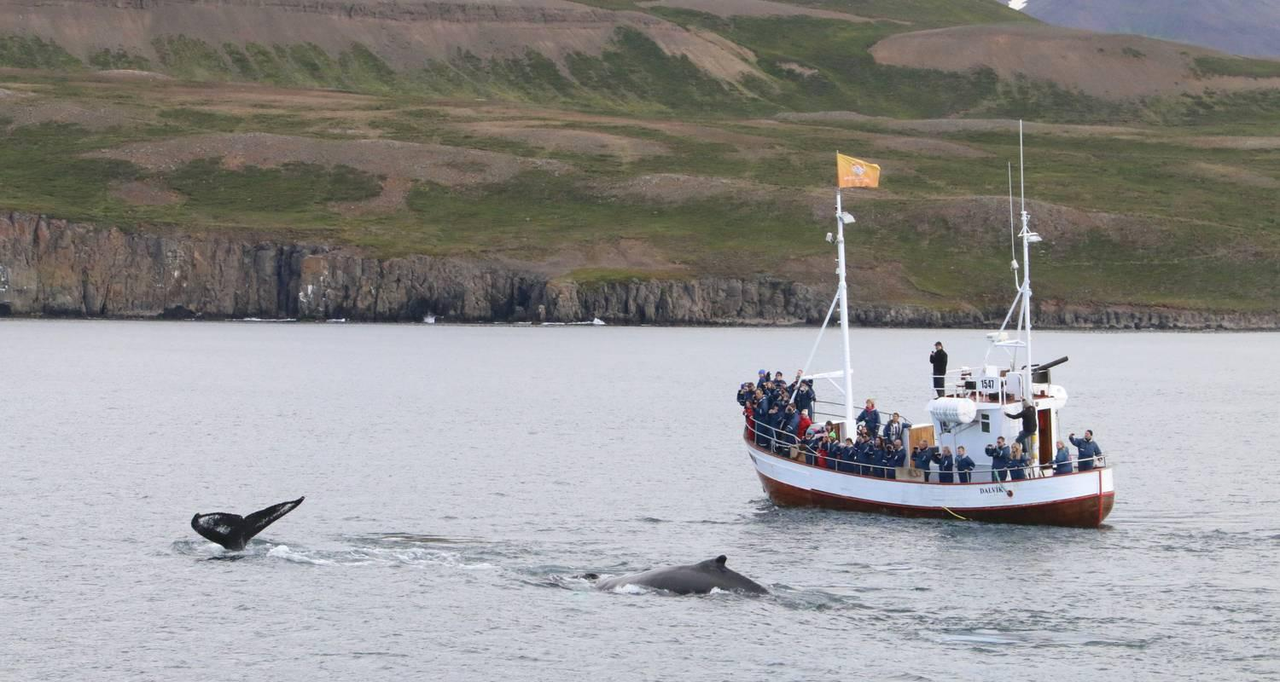

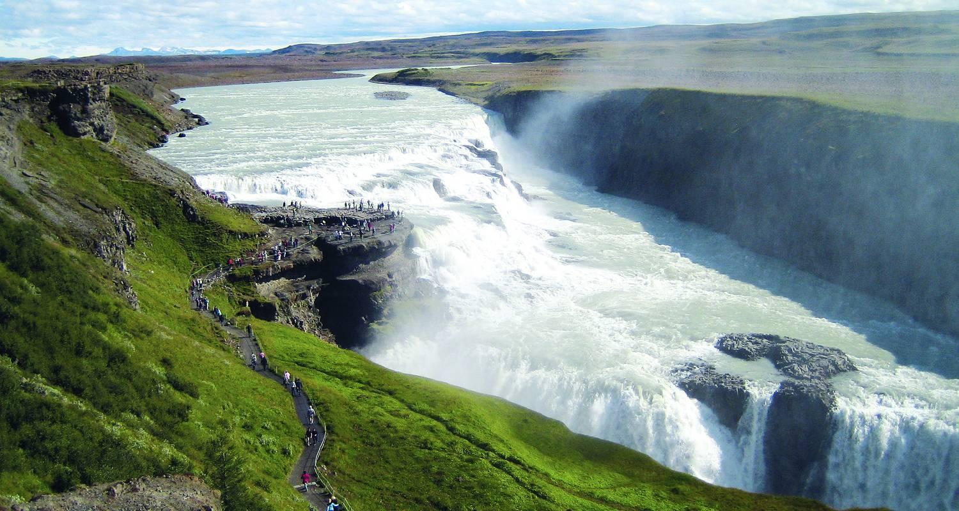

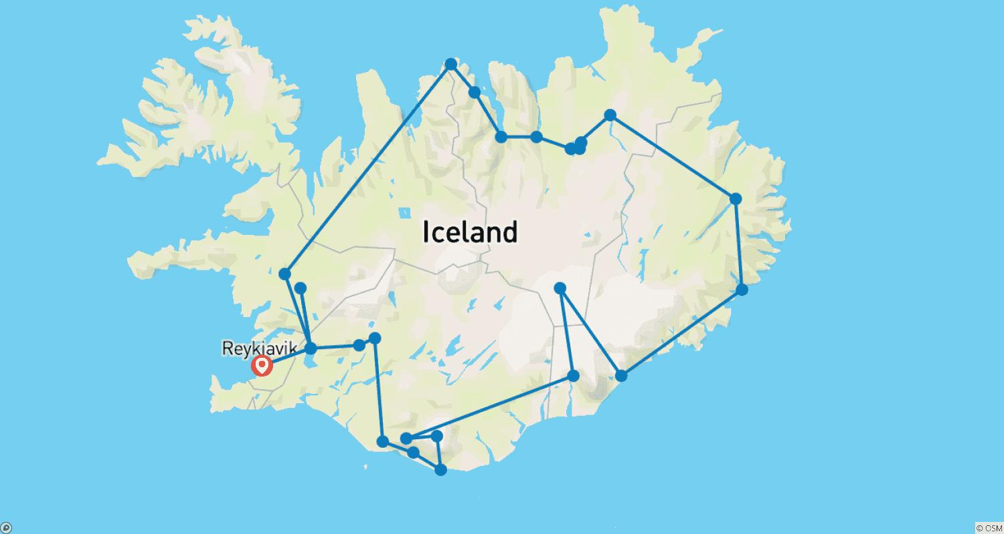

Tour ID: 108772  
Tour Name: 7 Day - Complete Iceland

Tour destinations: ['Reykjavik', 'Thingvellir National Park', 'Dover', 'Gullfoss', 'Seljaland', 'Skogafoss', 'Reynisfjara', 'Skaftafell', 'Vatnajokull National Park', 'Jokulsarlon', 'Djupivogur', 'Egilsstadir', 'Dettifoss', 'Mount Namaskard', 'Hverfjall Volcano', 'Myvatn', 'Akureyri', 'Dalvik', 'Siglufjordur', 'Grábrók Volcano', 'Reykholt', 'Borgarnes', 'Snaefellsjokull National Park', 'Arnarstapi', 'Hellnar', 'Djupalonssandur', 'Kirkjufell Mountain']

Tour destinations images:

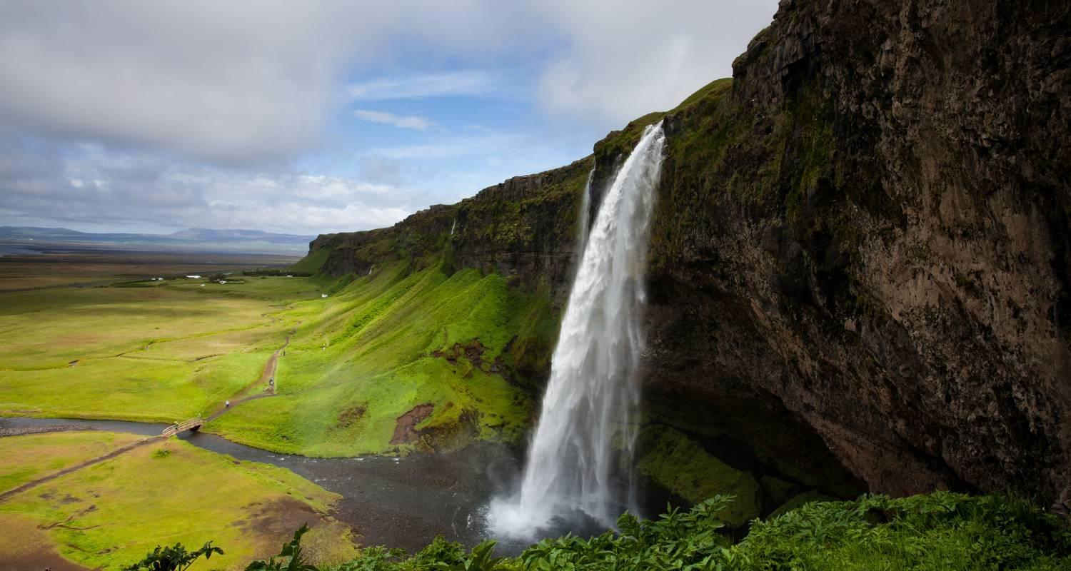

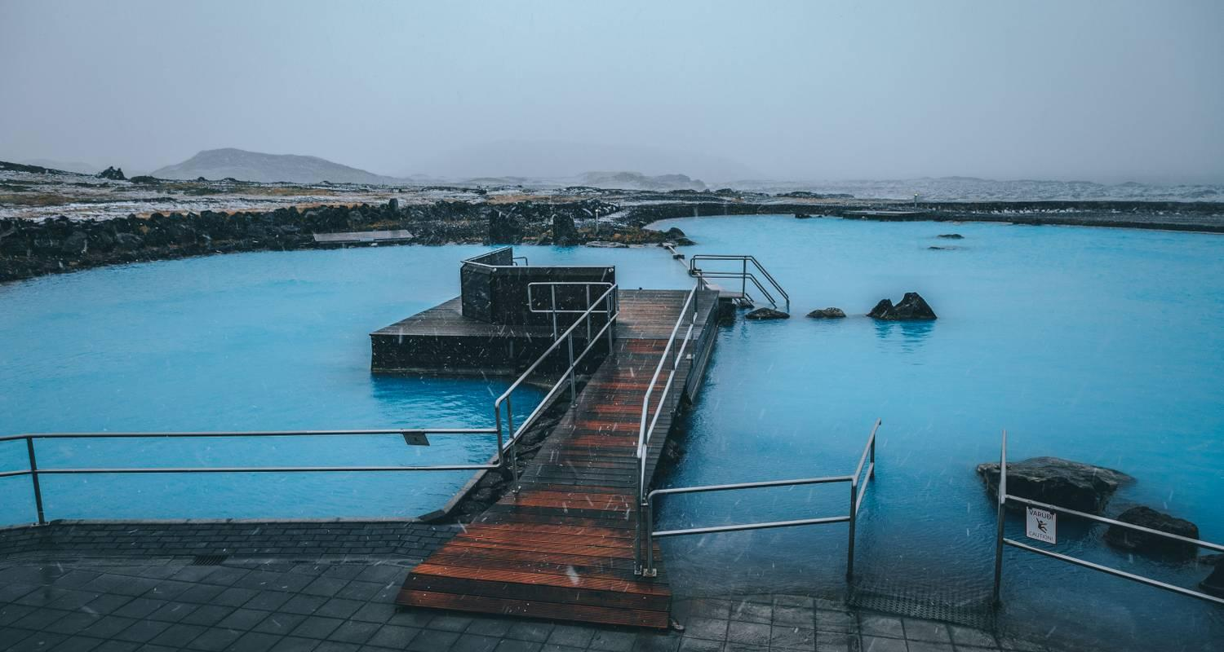

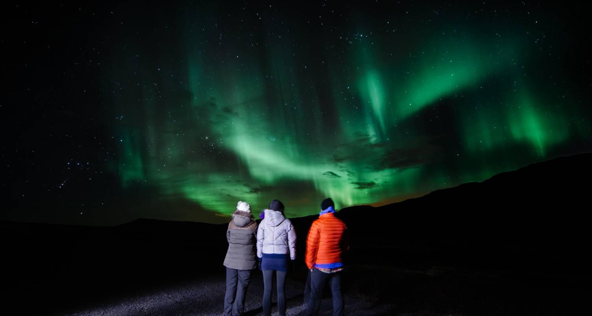

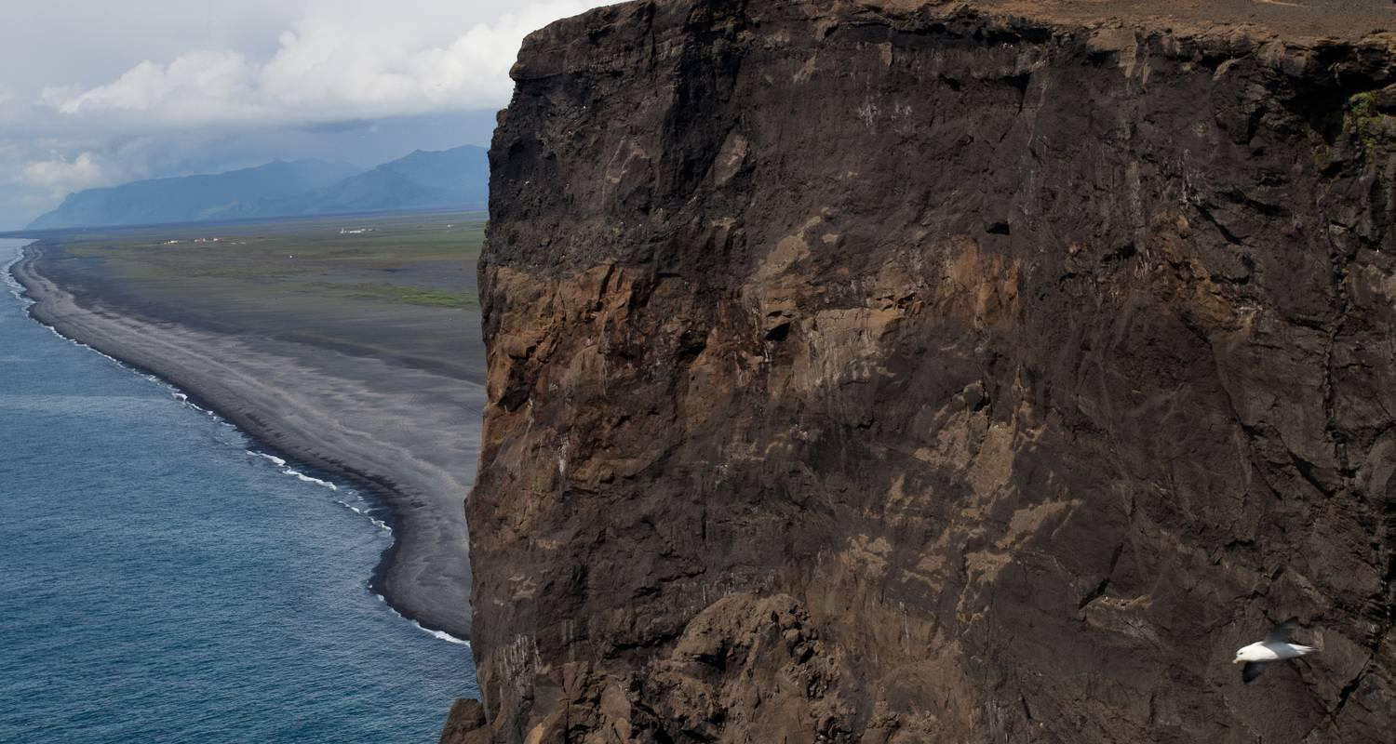

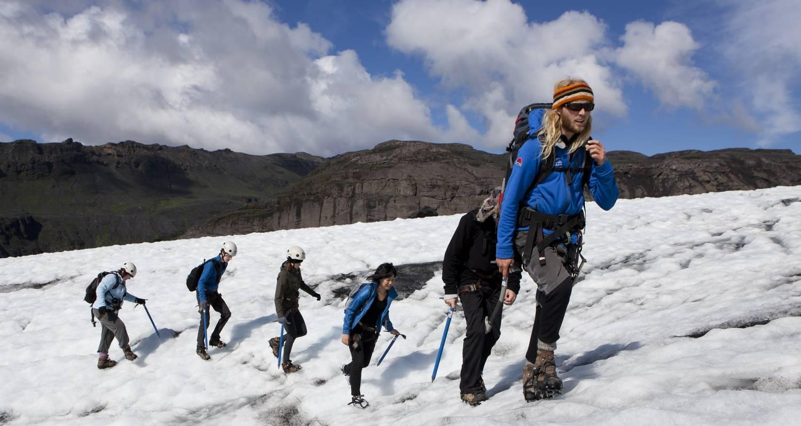





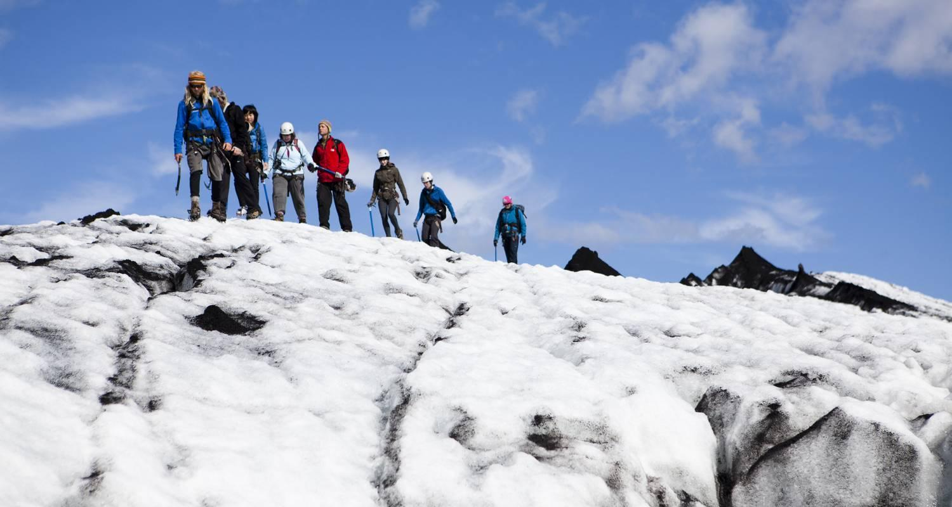

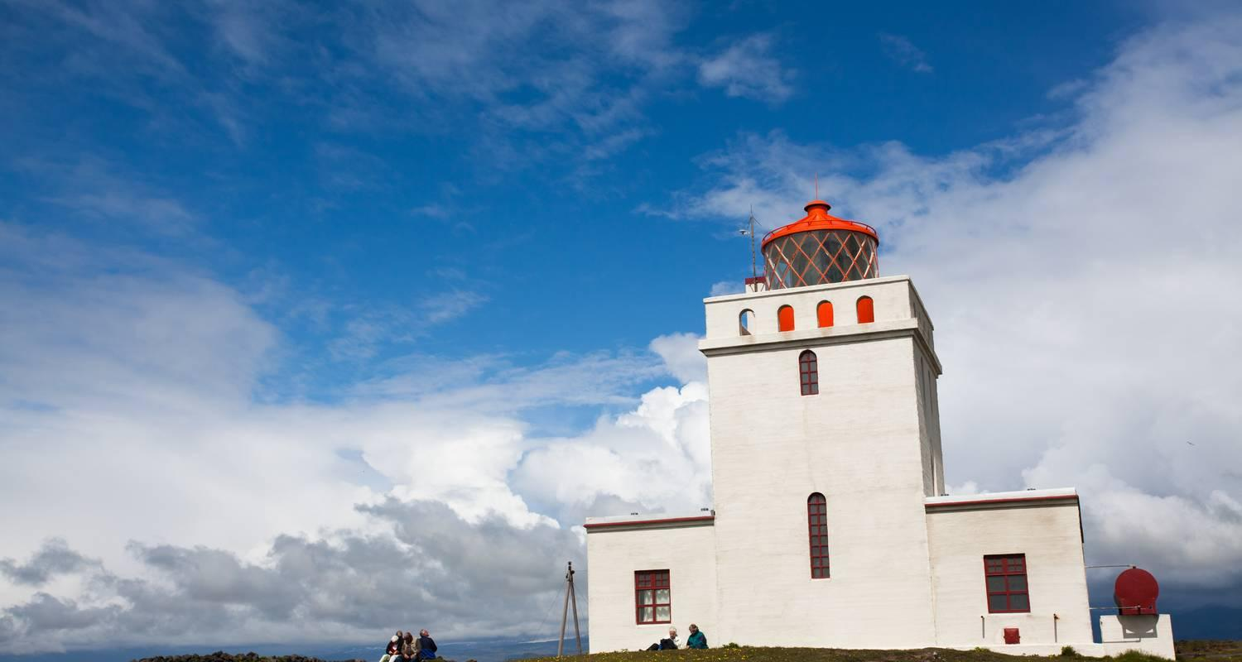



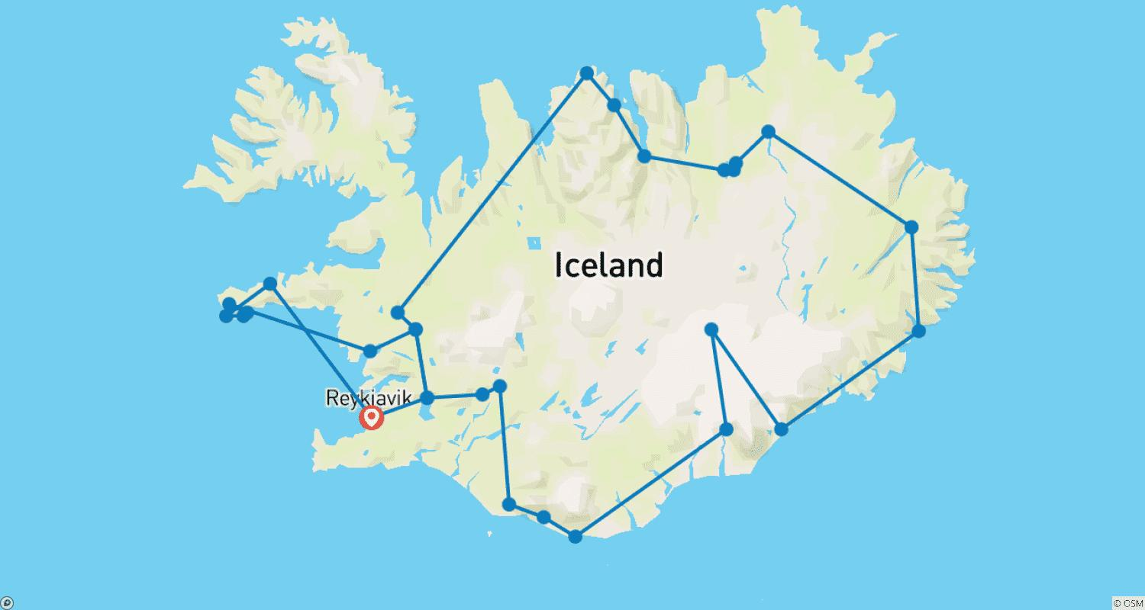

Tour ID: 111556  
Tour Name: 5 Days Christmas & Northern Lights Adventure

Tour destinations: ['Reykjavik', 'Reykjanesviti', 'Gunnuhver', 'Blue Lagoon', 'Hella', 'Seljaland', 'Eyjafjallajokull', 'Skogafoss', 'Solheimajokull', 'Reynisfjara', 'Vik', 'Geysir', 'Gullfoss', 'Thingvellir National Park']

Tour destinations images:

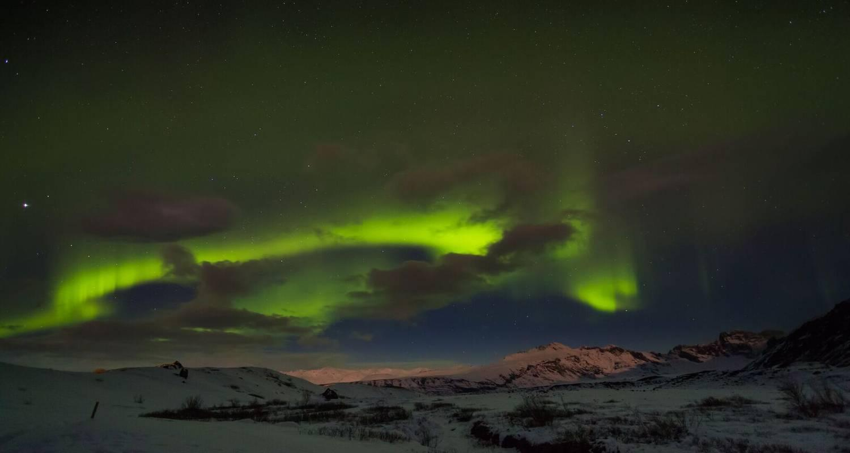

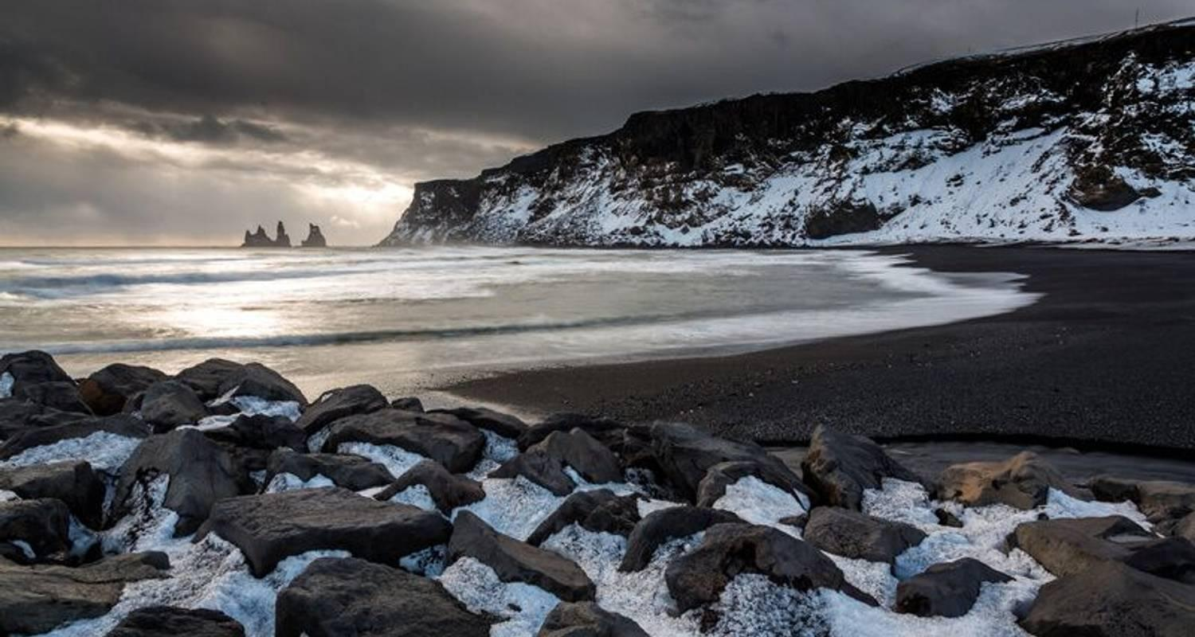

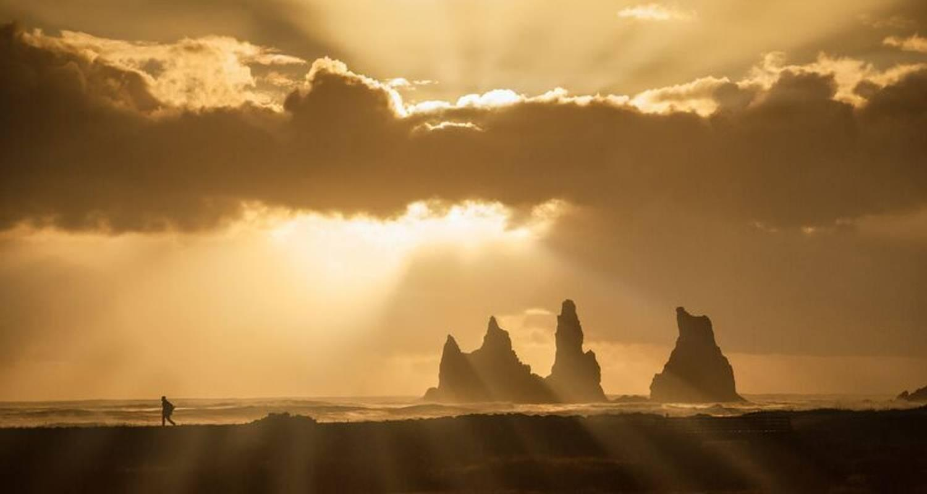

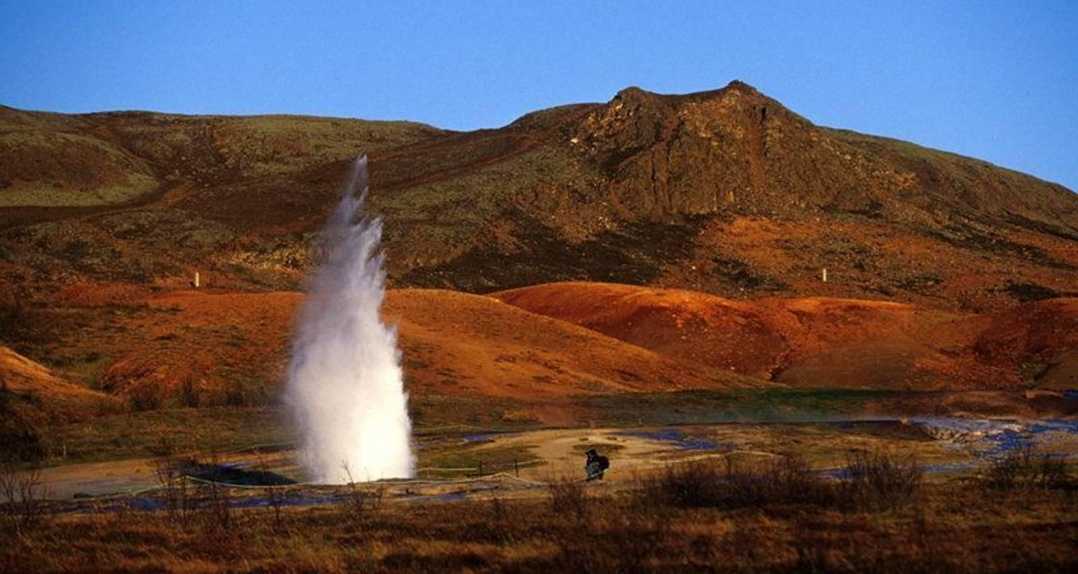

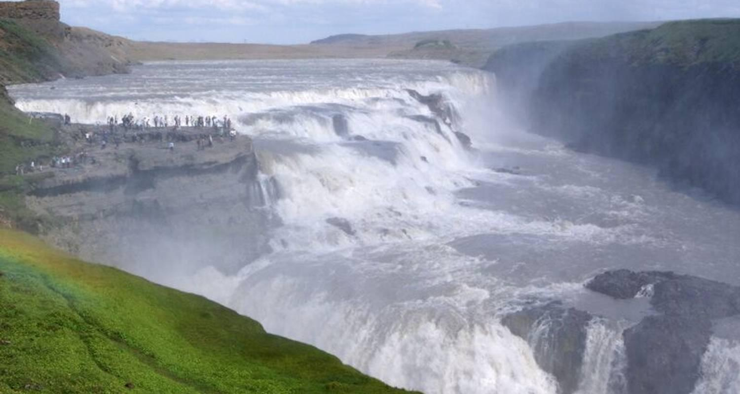

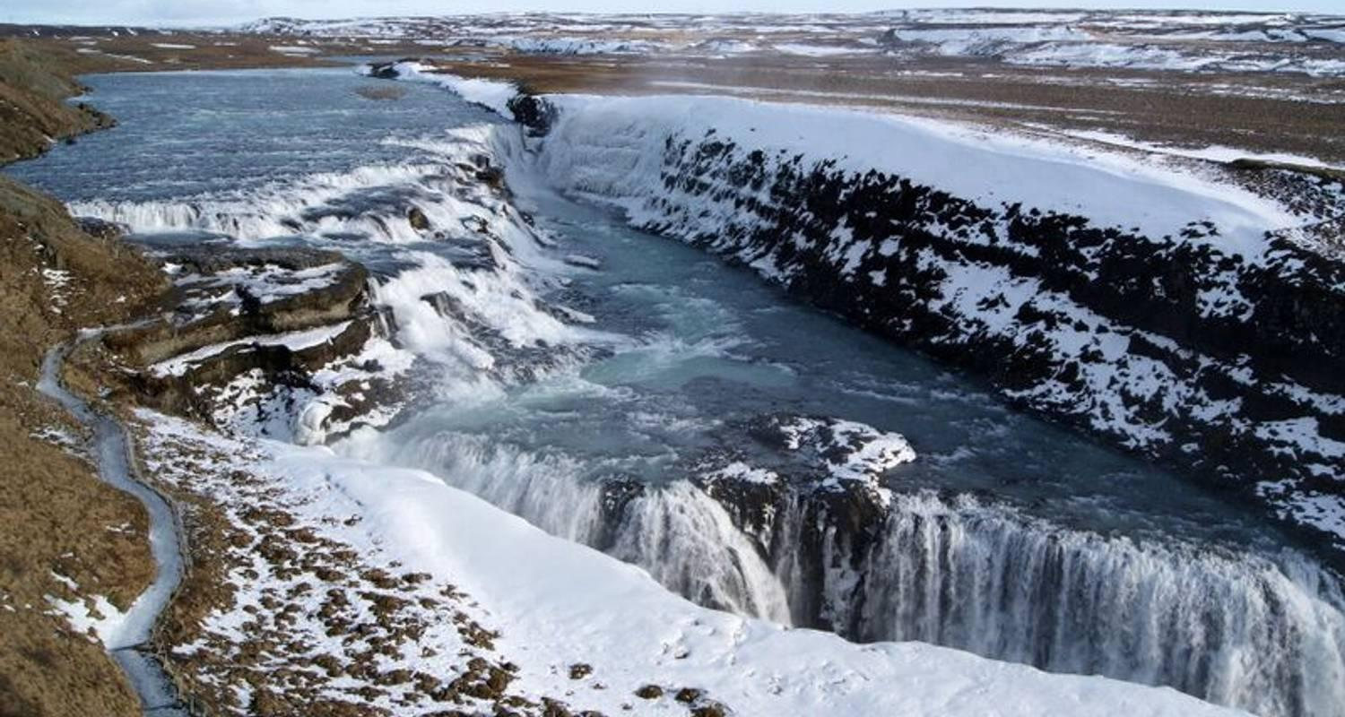

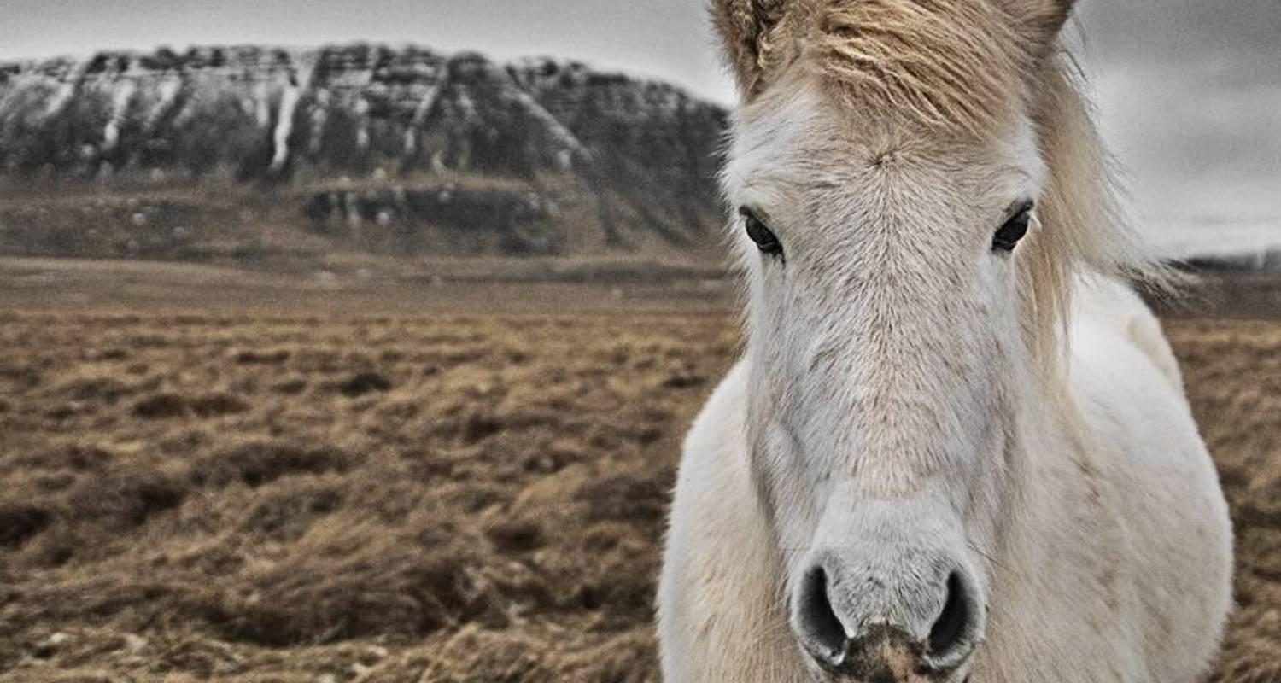

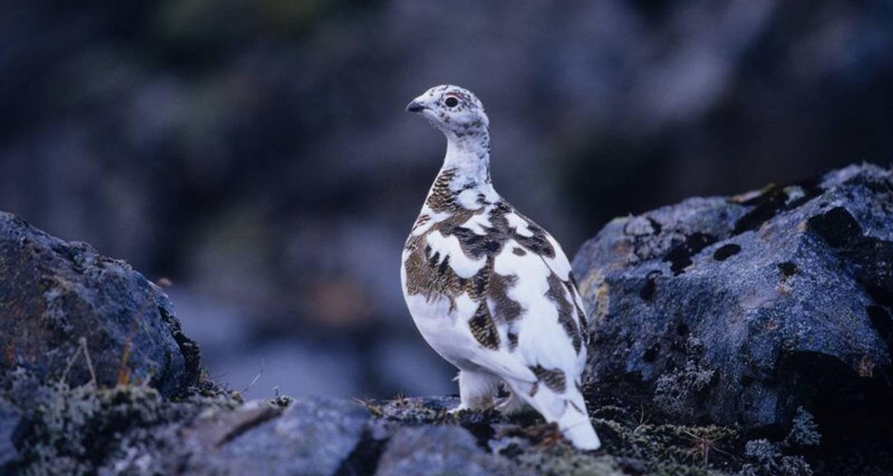

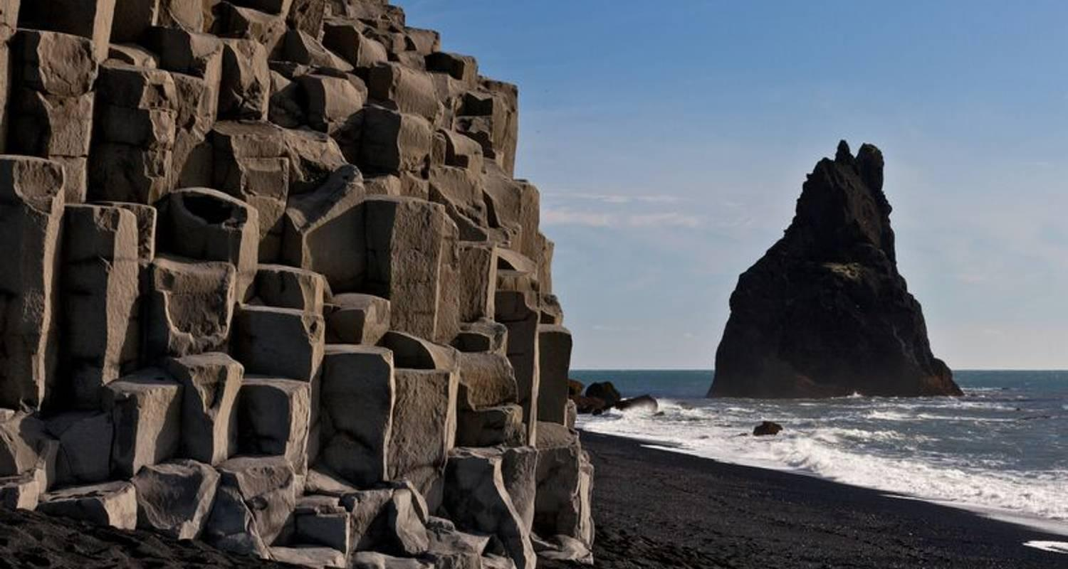

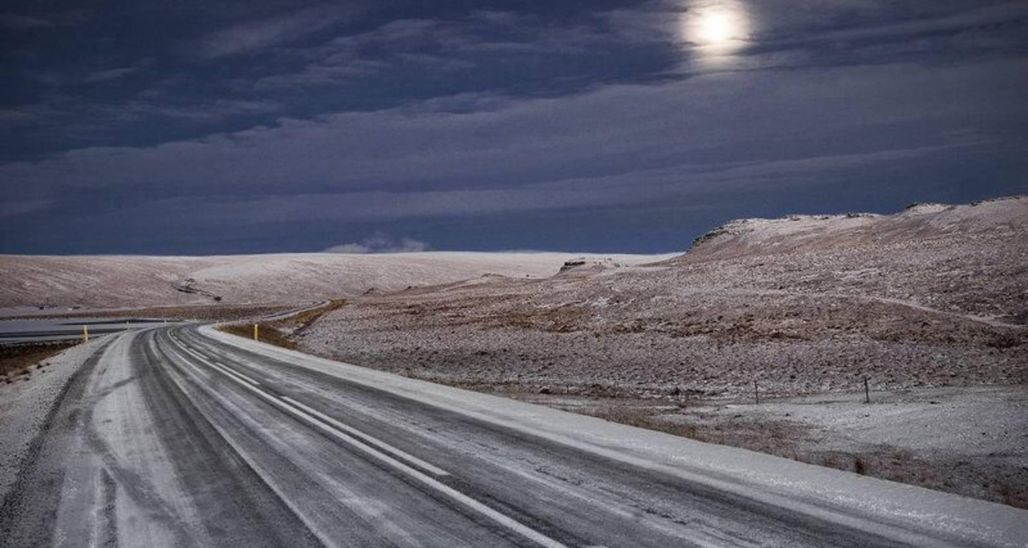

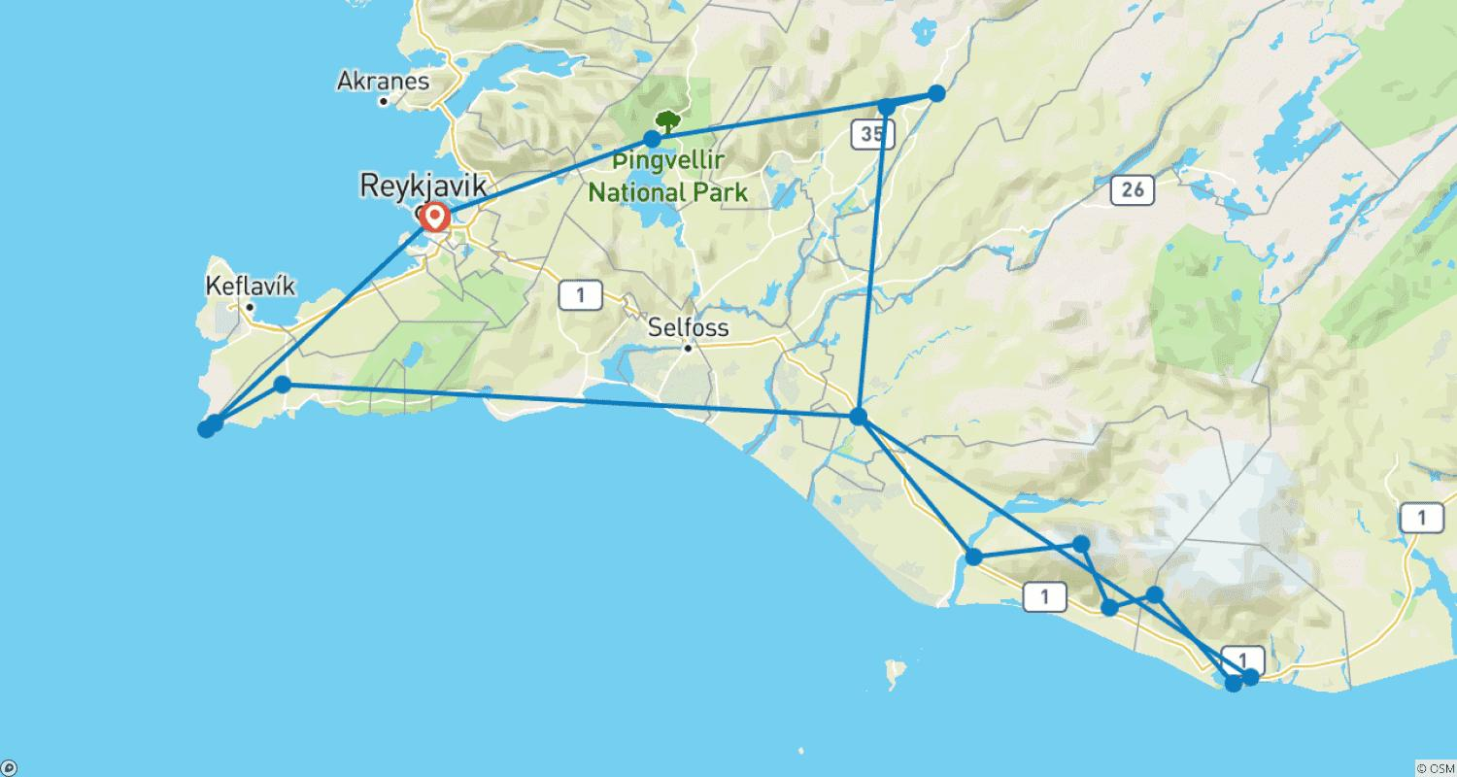

Tour ID: 112659  
Tour Name: 3 Day Family Package Iceland

Tour destinations: ['Reykjavik', 'Thingvellir National Park', 'Geysir', 'Gullfoss', 'Kerid Volcano', 'Skogafoss', 'Reynisfjara', 'Vik', 'Solheimajokull', 'Seljaland', 'Borgarnes', 'Kirkjufell Mountain', 'Djupalonssandur', 'Arnarstapi']

Tour destinations images:

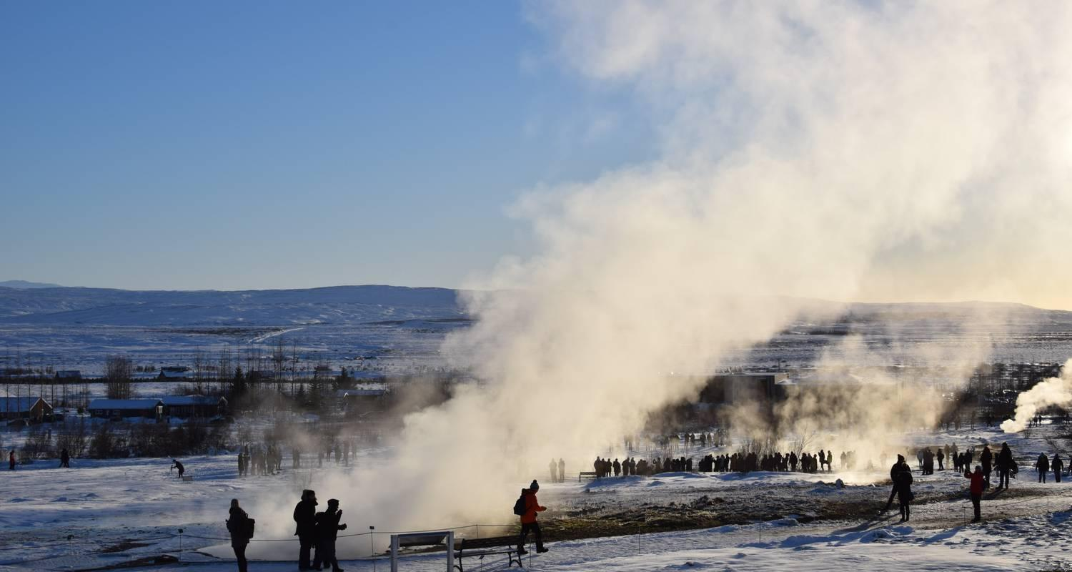

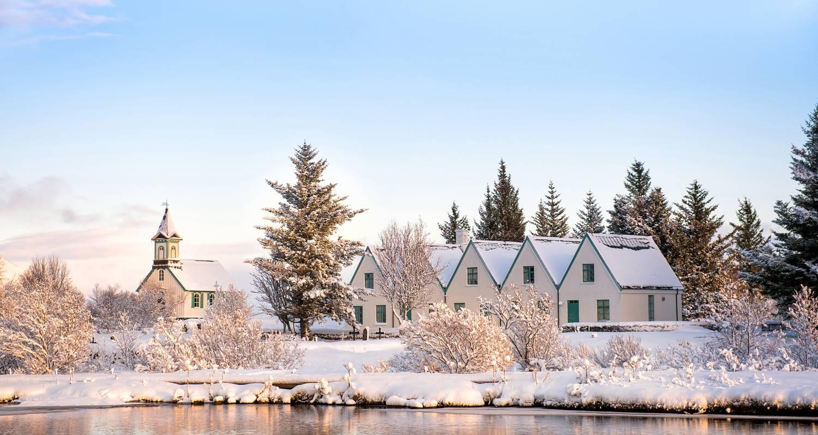

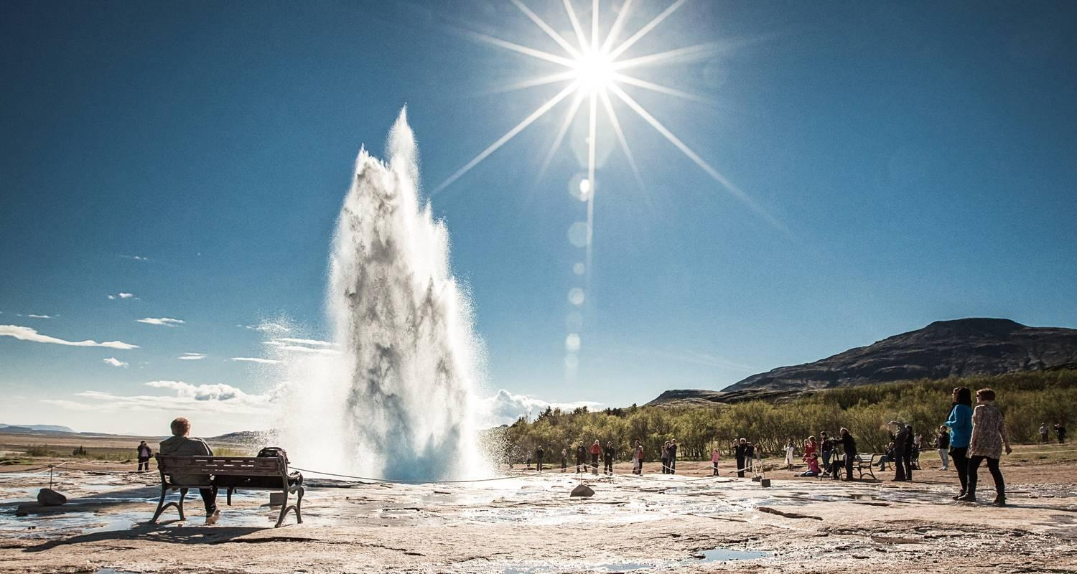

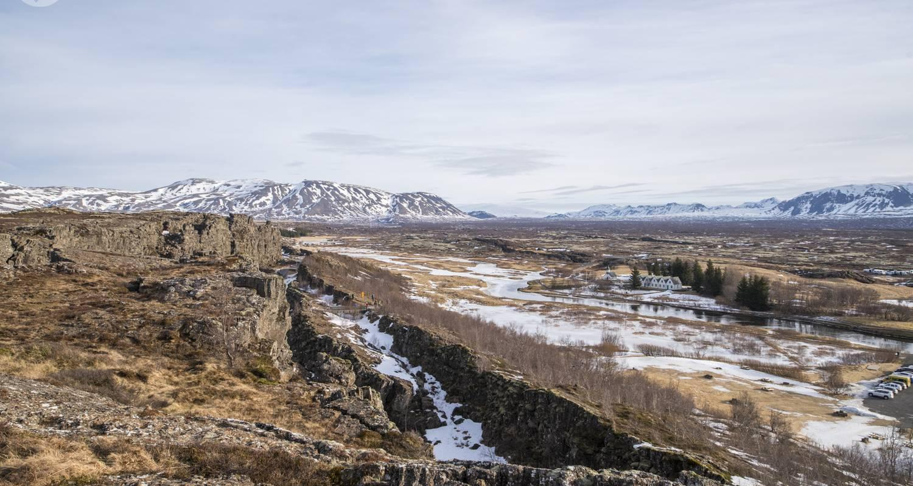

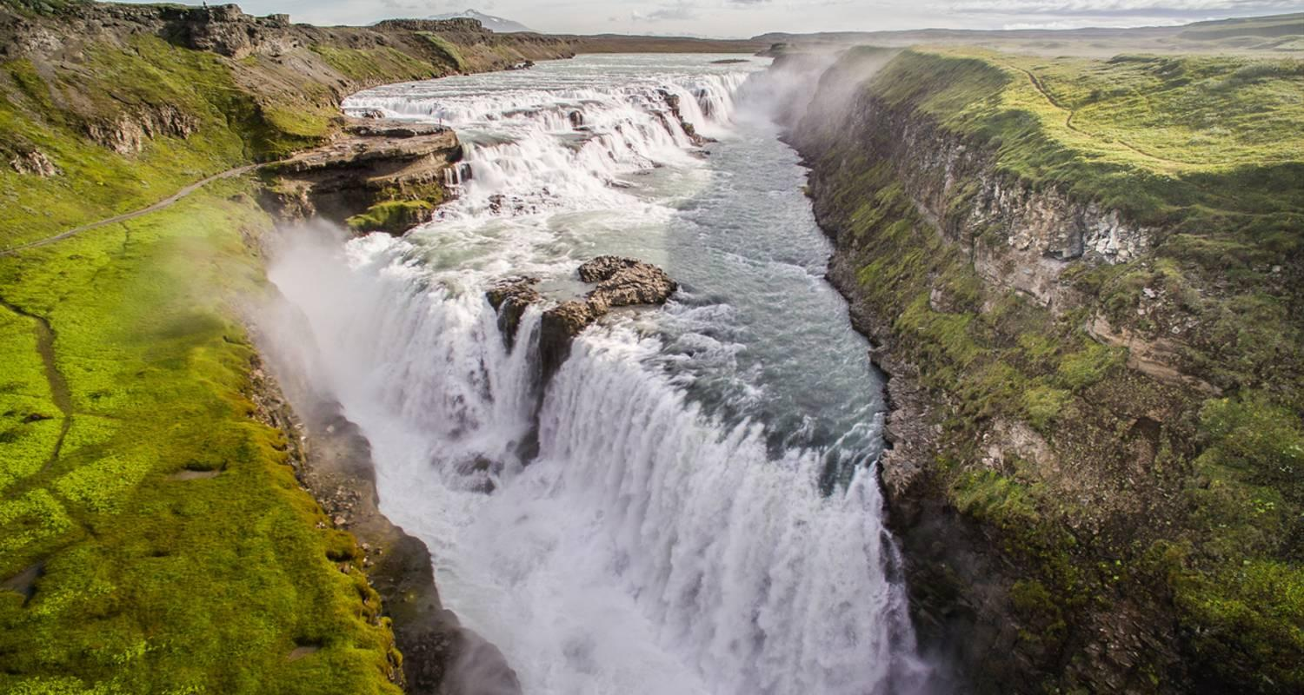

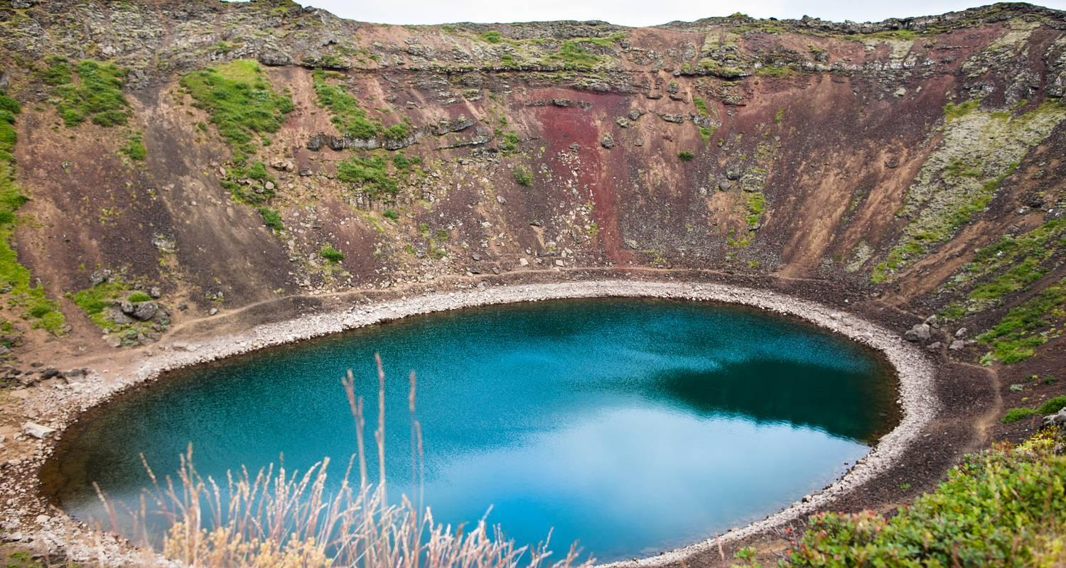

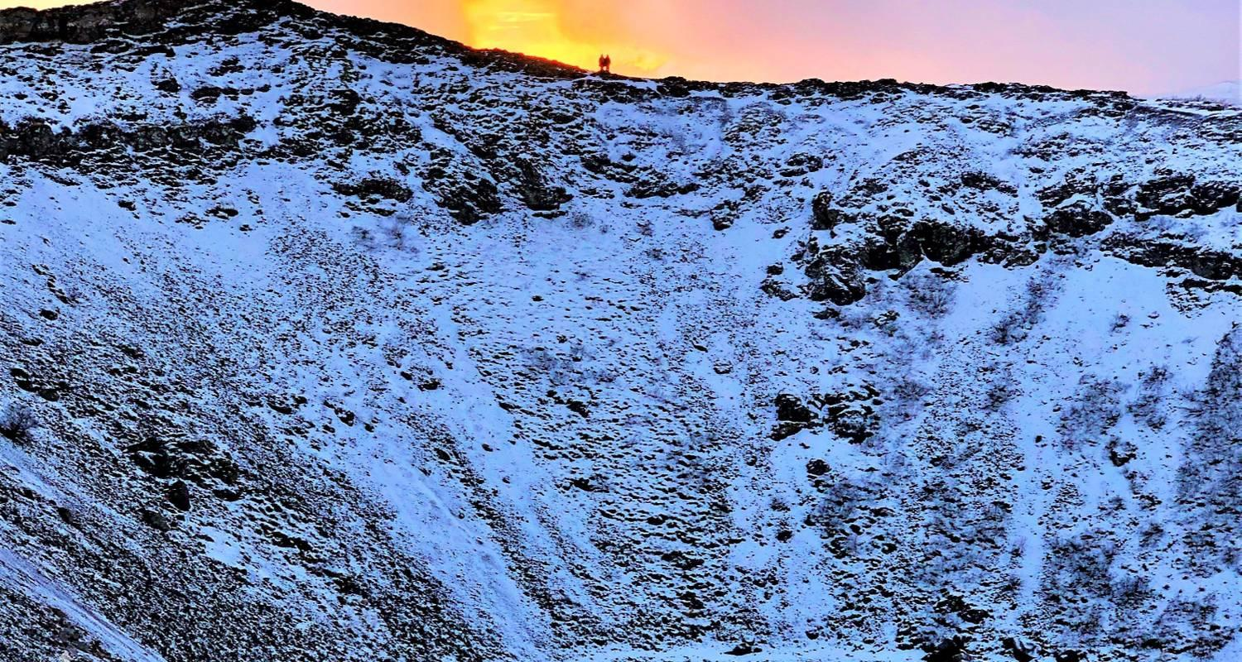

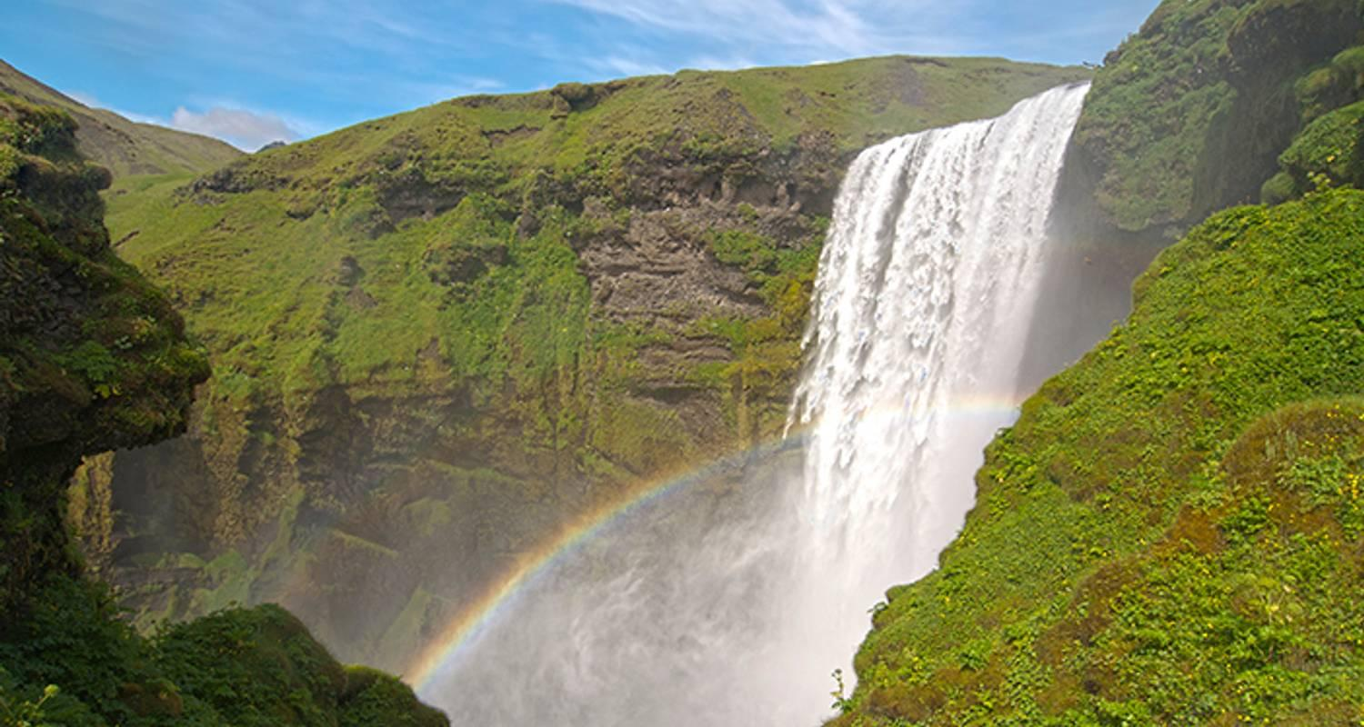

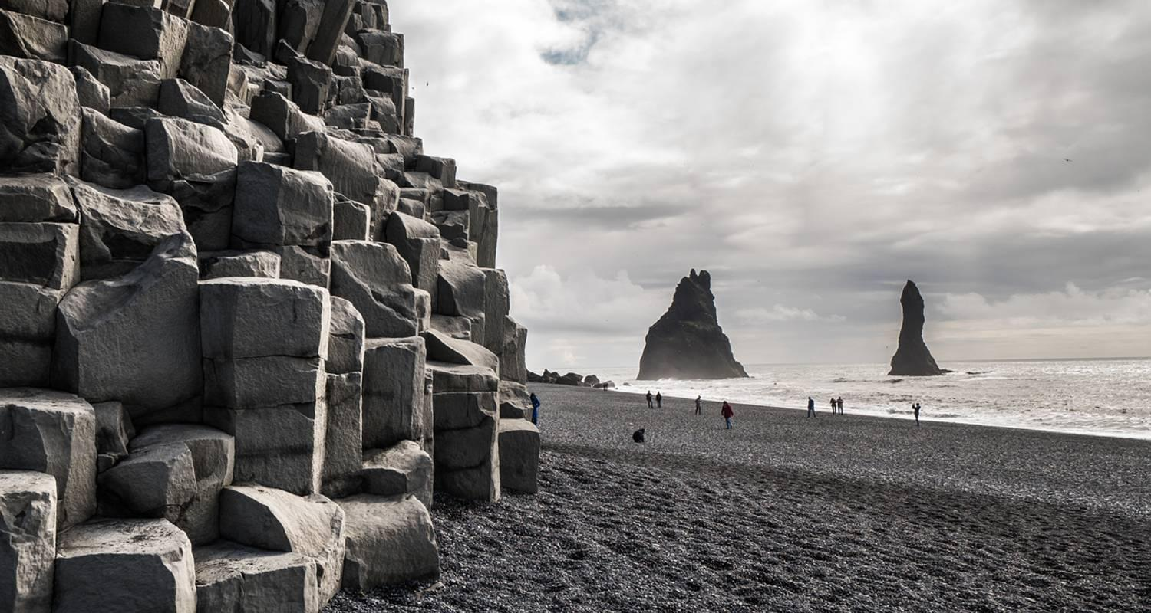

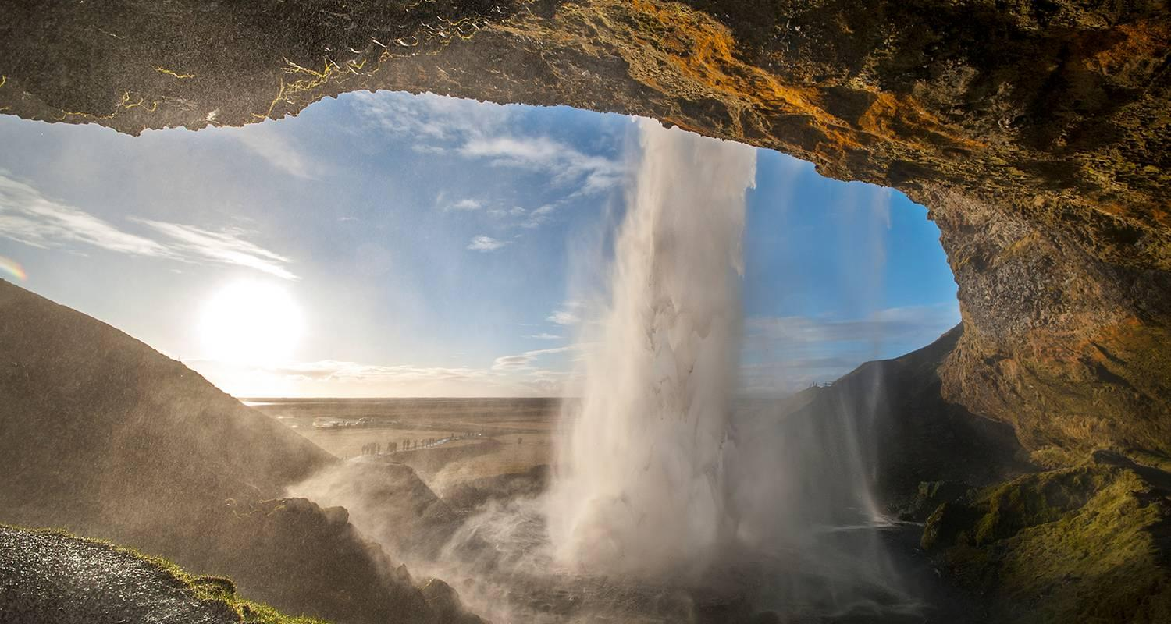

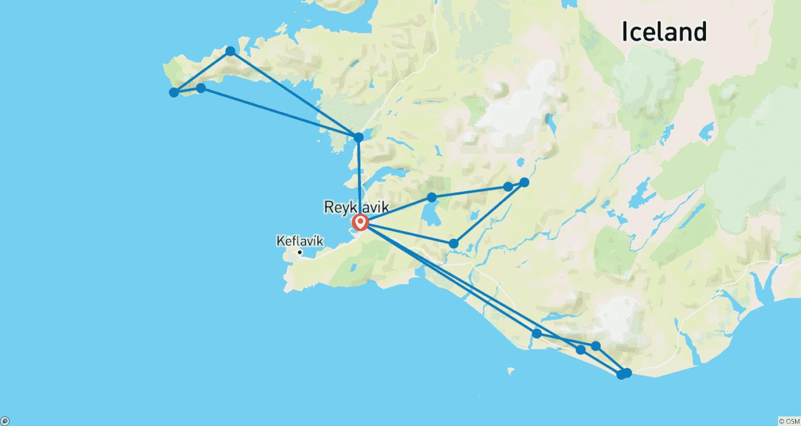

Tour ID: 115429  
Tour Name: Explore Iceland National Geographic Journeys

Tour destinations: ['Reykjavik', 'Skaftafell', 'Vik', 'Reynisfjara', 'Skogafoss', 'Selfoss', 'Gullfoss', 'Dover', 'Thingvellir National Park', 'Snaefellsjokull National Park']

Tour destinations images:

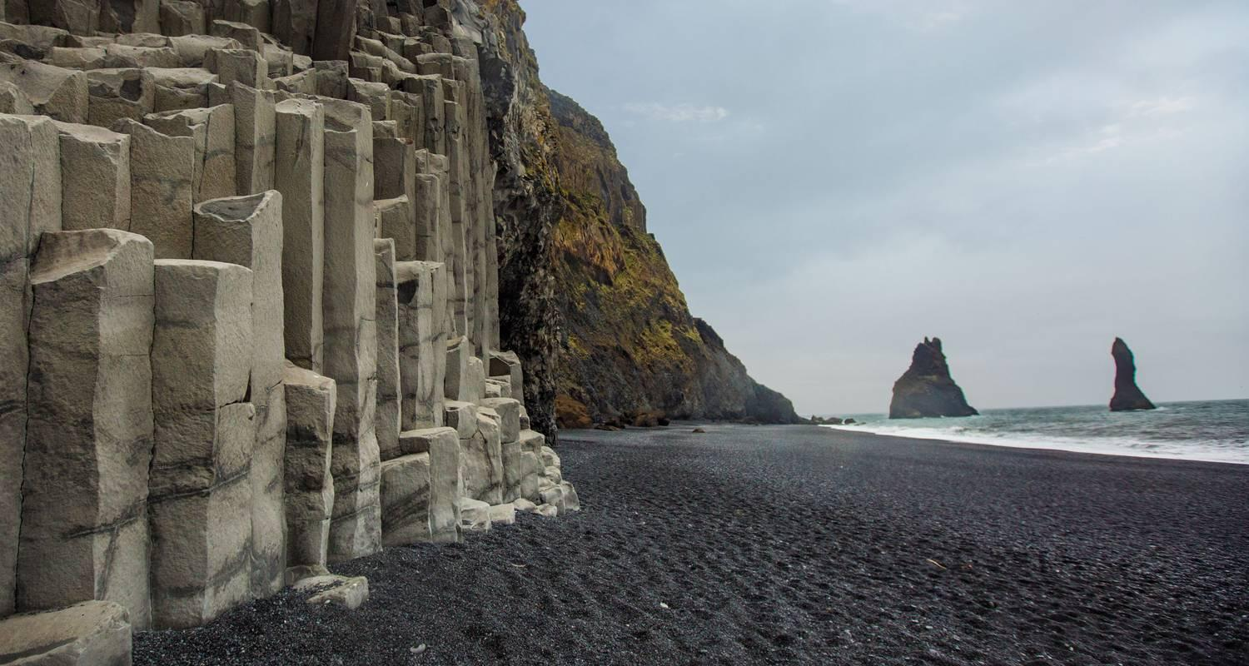

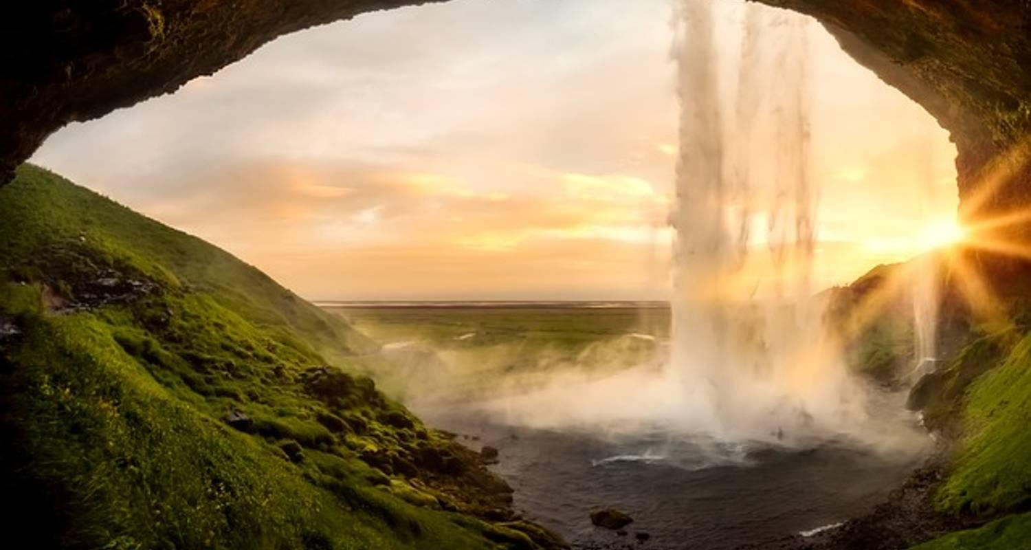

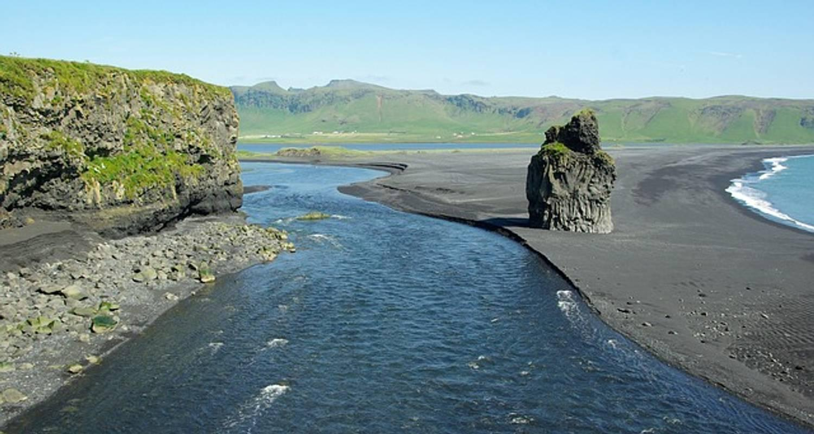

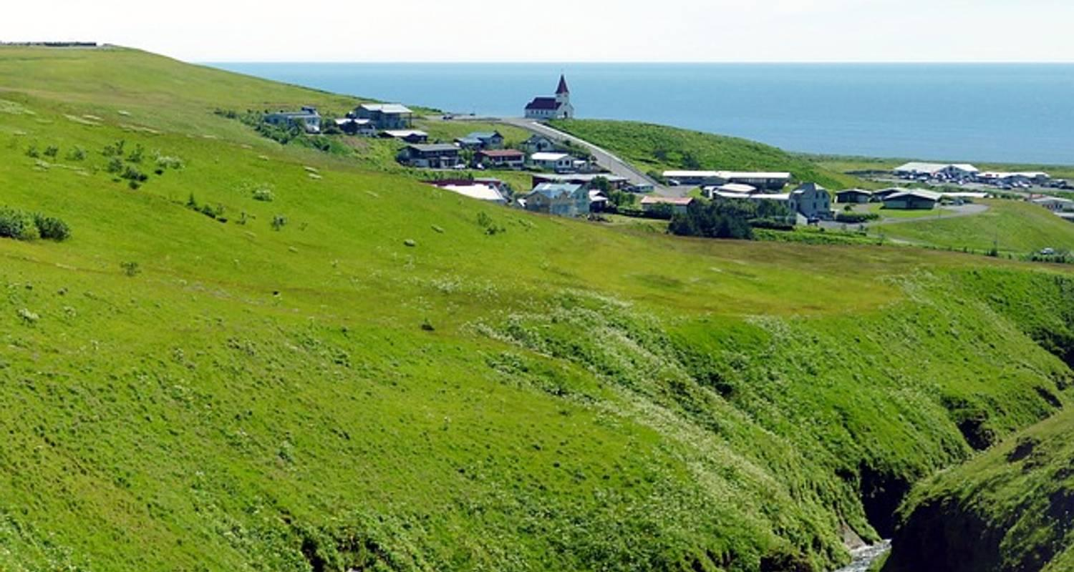

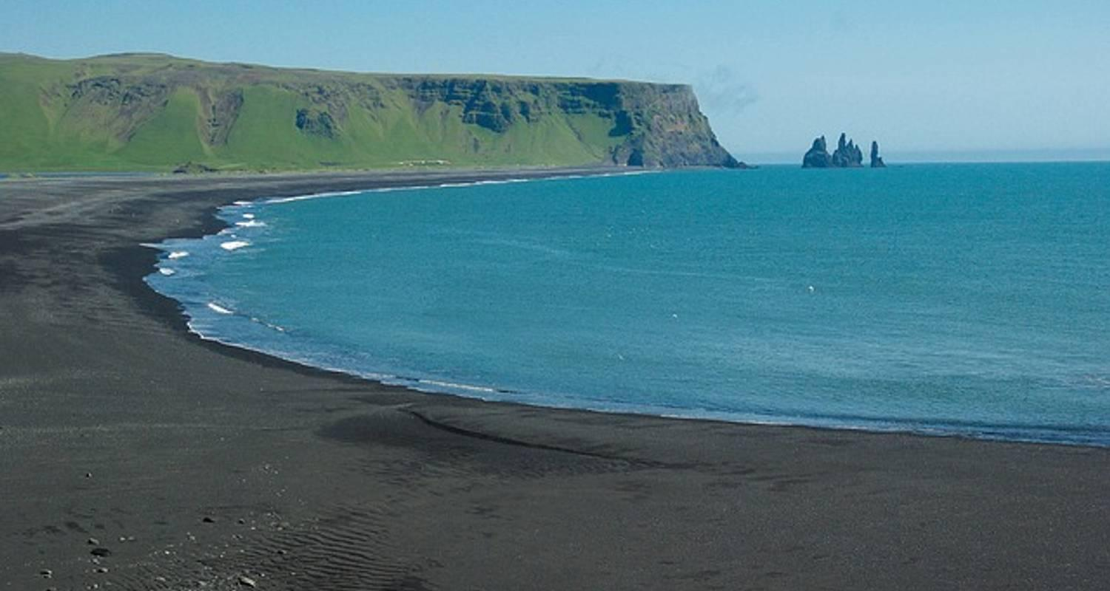

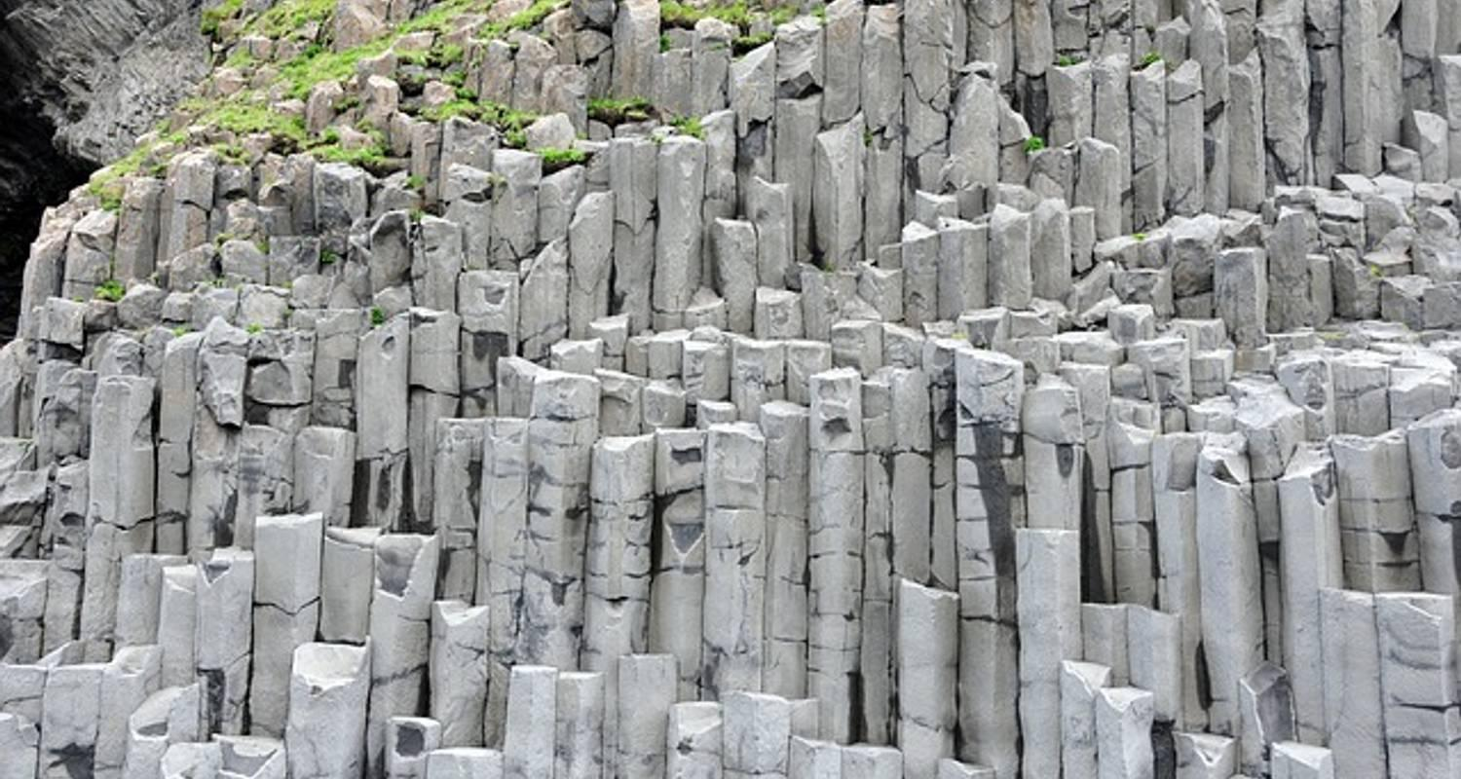

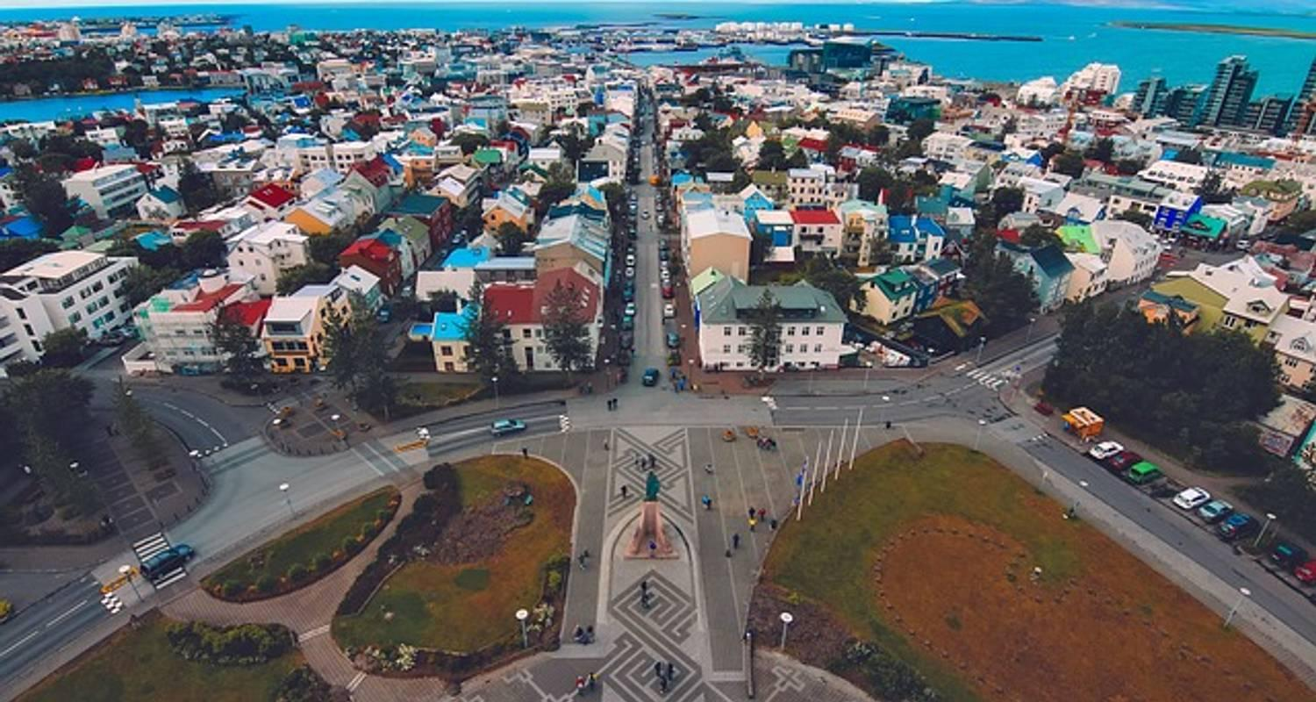

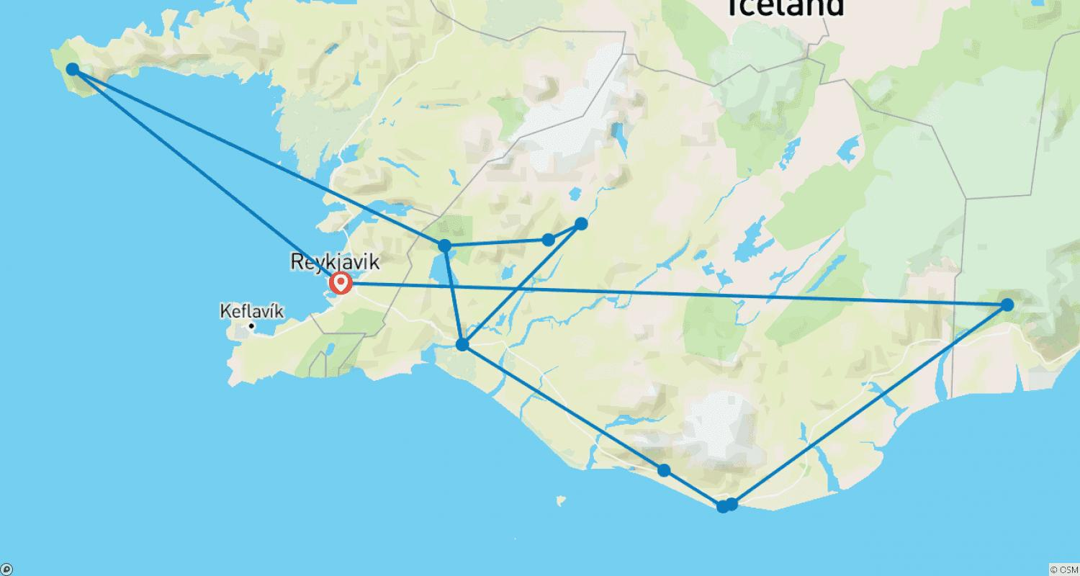

Tour ID: 117000  
Tour Name: Iceland Explorer

Tour destinations: ['Reykjavik', 'Geysir', 'Gullfoss', 'Vik', 'Hofn', 'Egilsstadir', 'Myvatn', 'Akureyri', 'Borgarnes']

Tour destinations images:

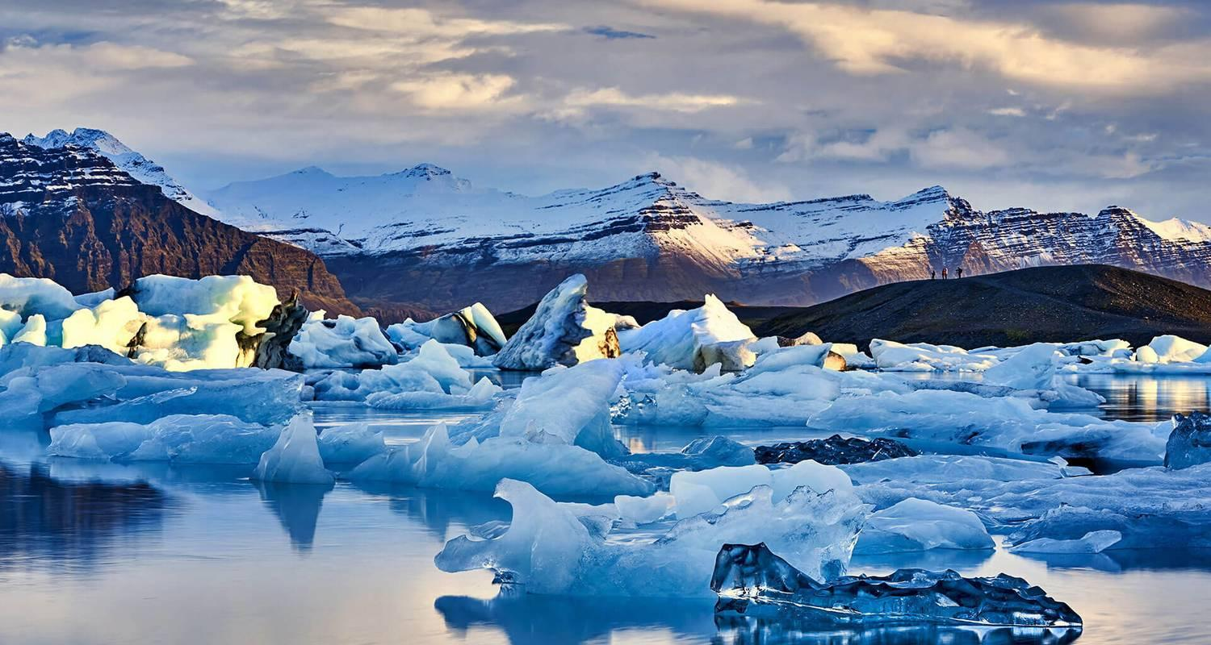

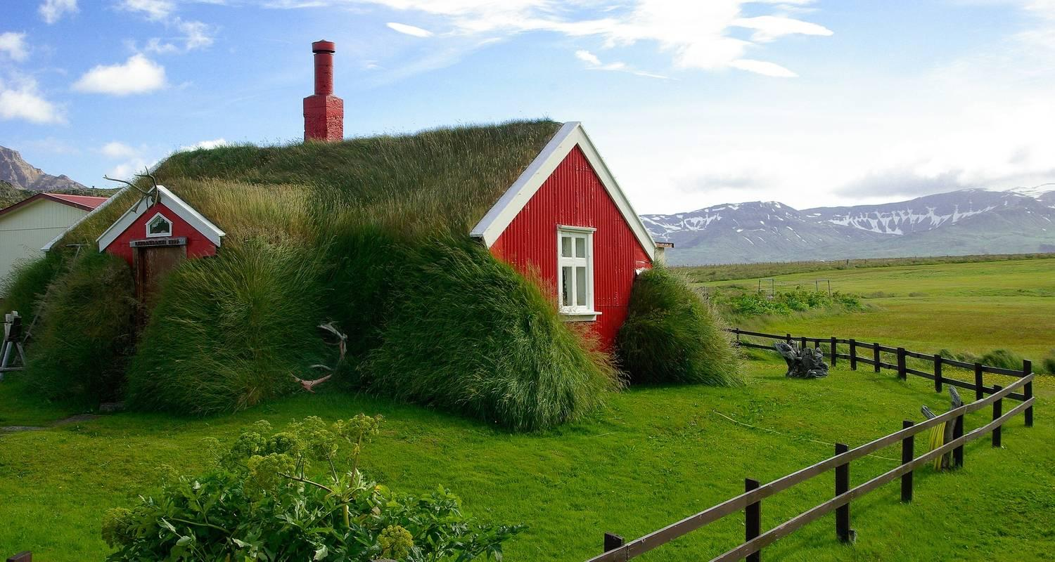

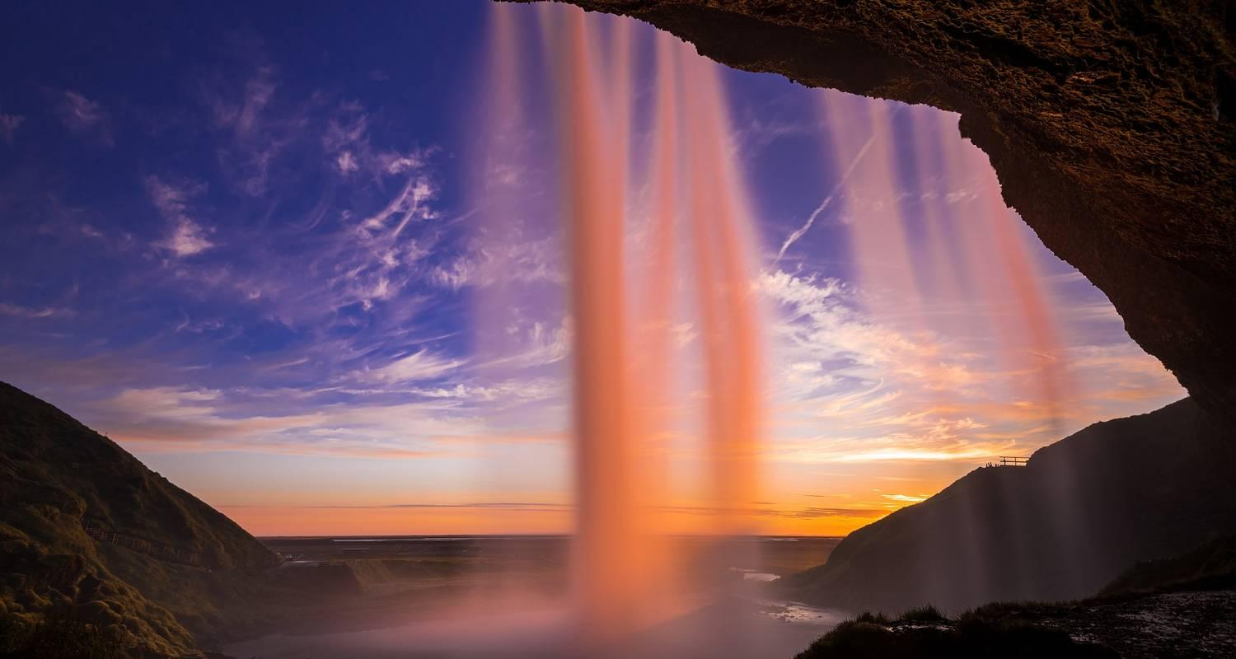

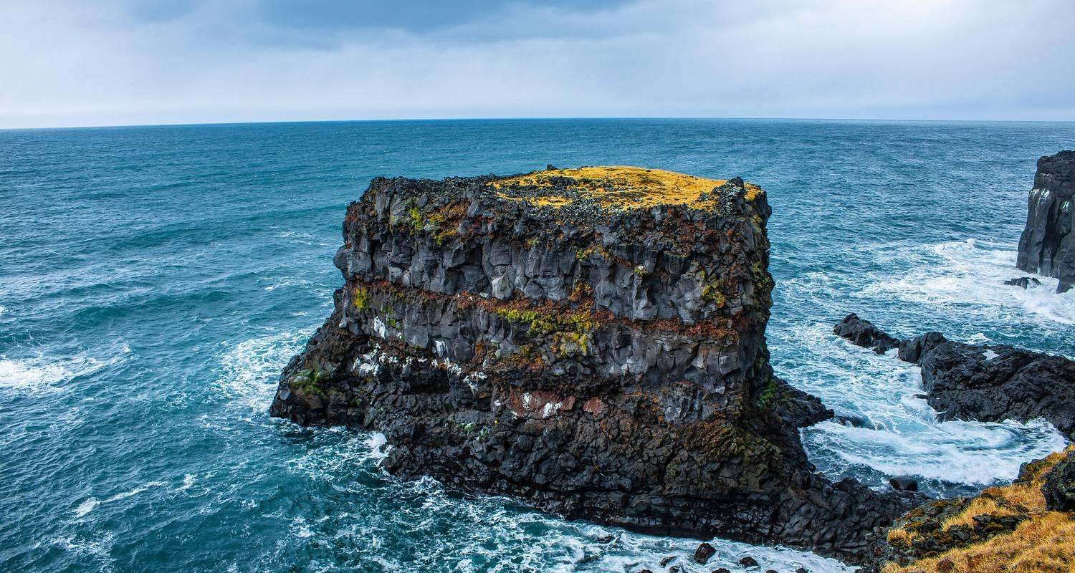

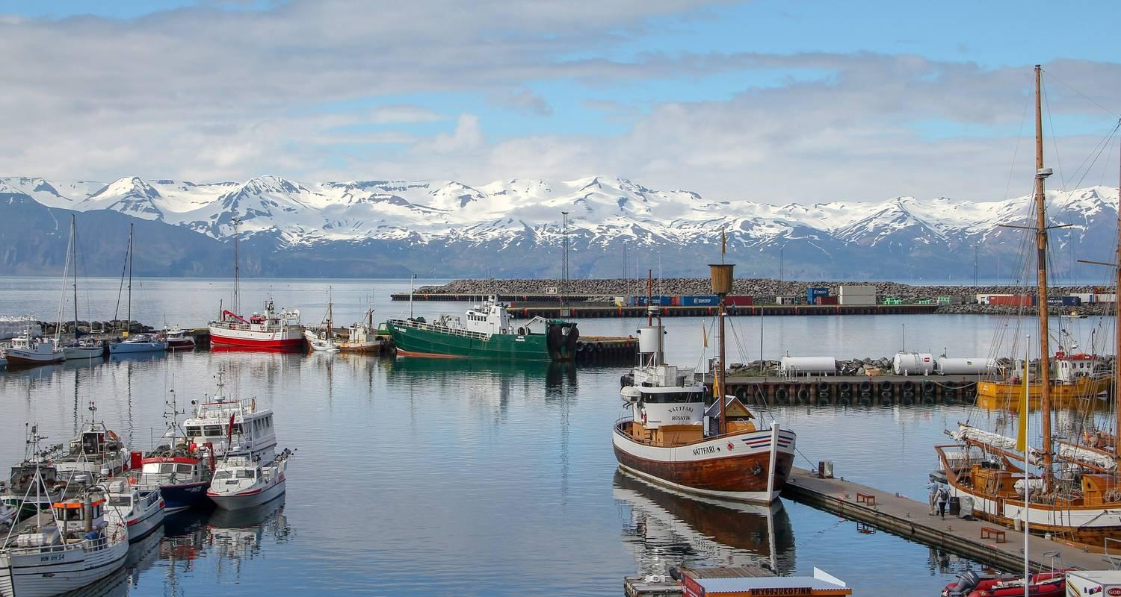

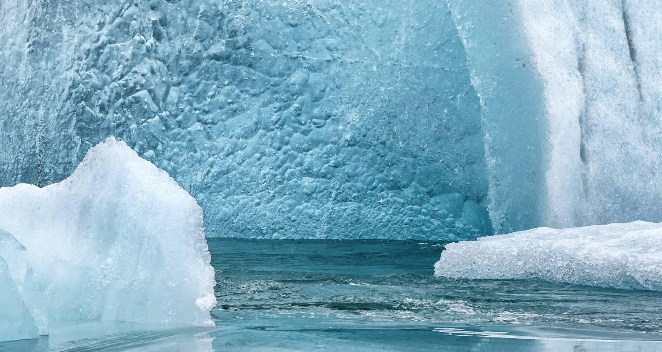

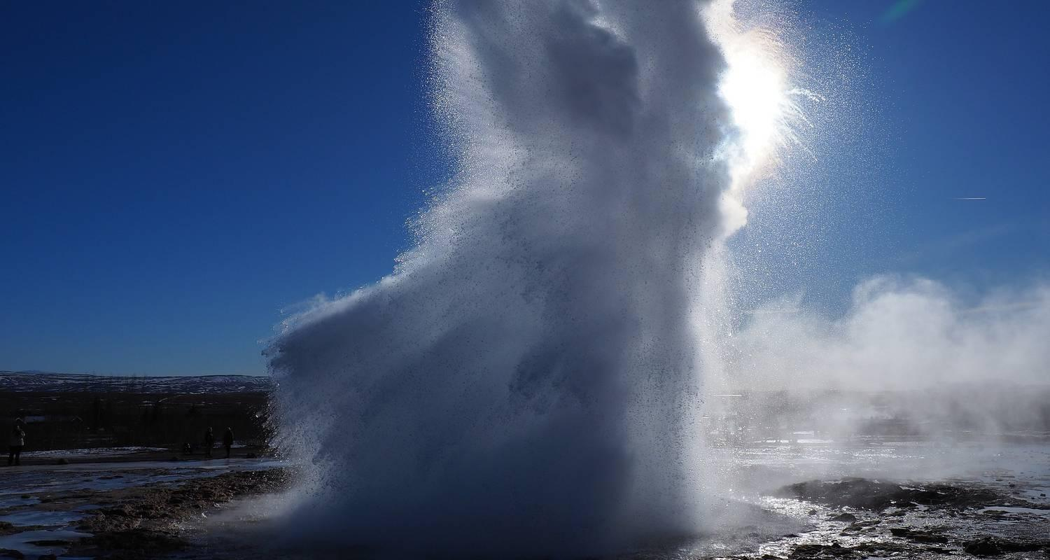

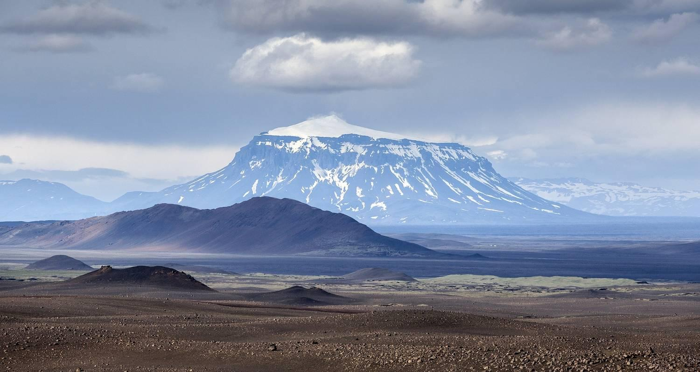

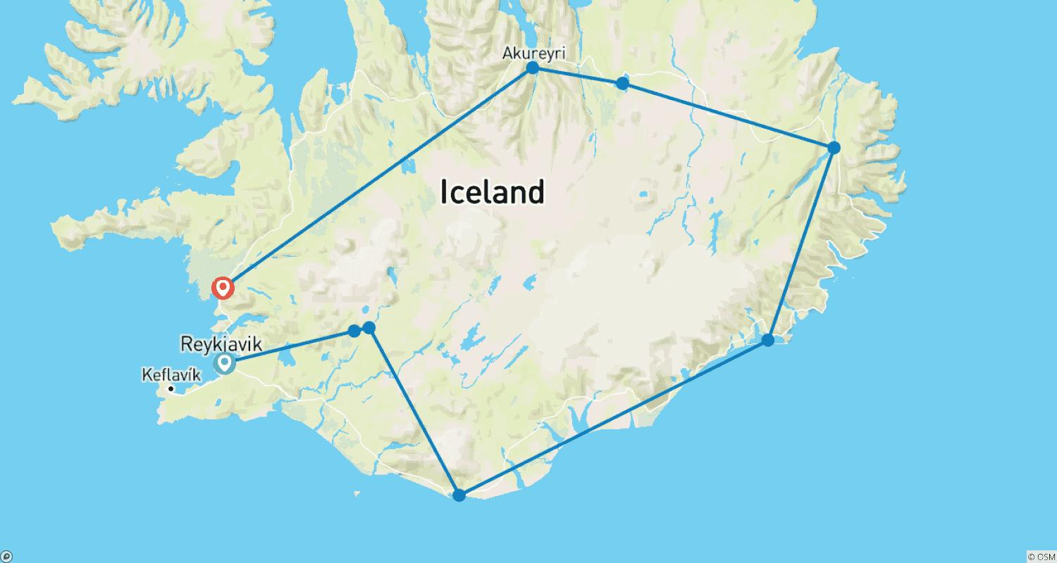

Tour ID: 127312  
Tour Name: 8 Day - Ultimate Iceland Highlight Hitter

Tour destinations: ['Reykjavik', 'Thingvellir National Park', 'Dover', 'Gullfoss', 'Seljaland', 'Skogafoss', 'Vik', 'Skaftafell', 'Jokulsarlon', 'Hofn', 'Djupivogur', 'Egilsstadir', 'Dettifoss', 'Myvatn', 'Godafoss', 'Akureyri', 'Dalvik', 'Siglufjordur', 'Reykholt', 'Borgarnes', 'Snaefellsjokull National Park', 'Landmannalaugar', 'Hekla Volcano']

Tour destinations images:

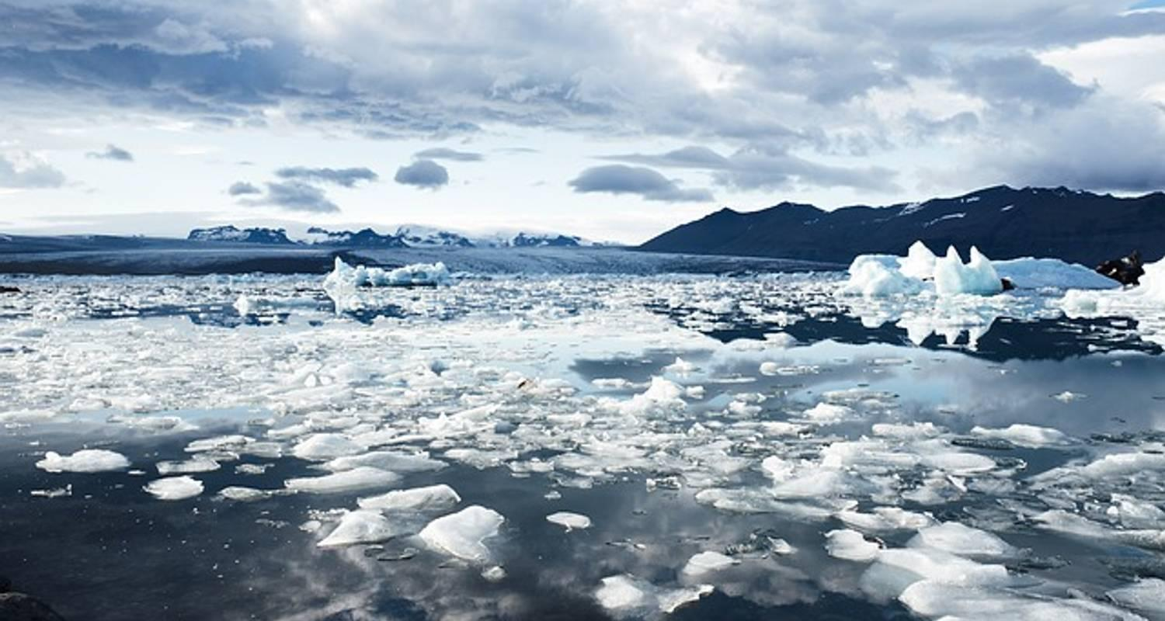



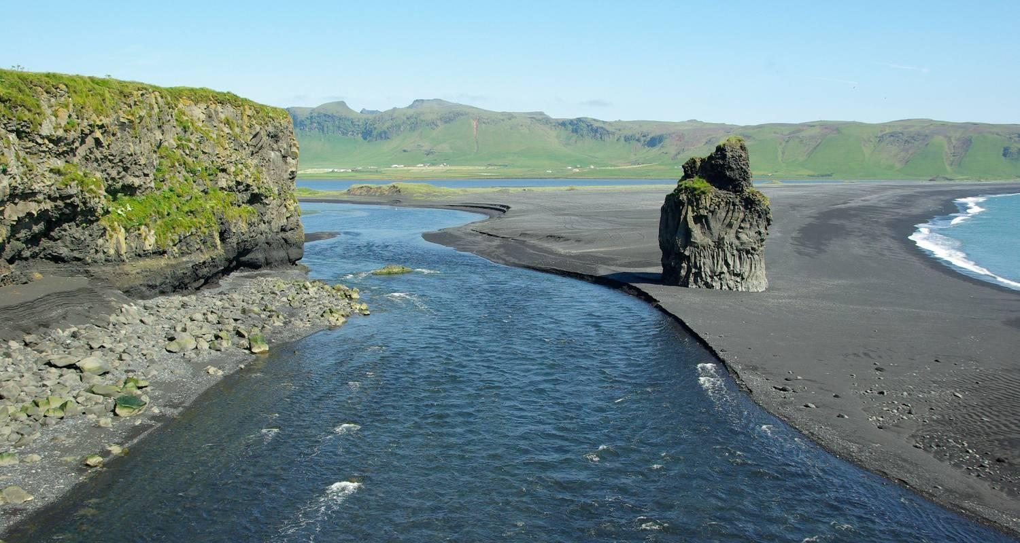













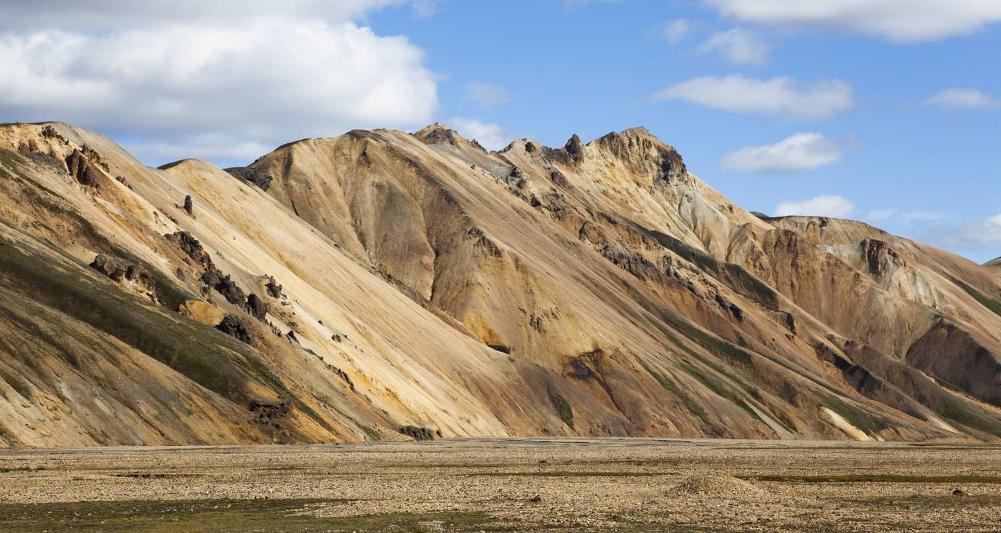

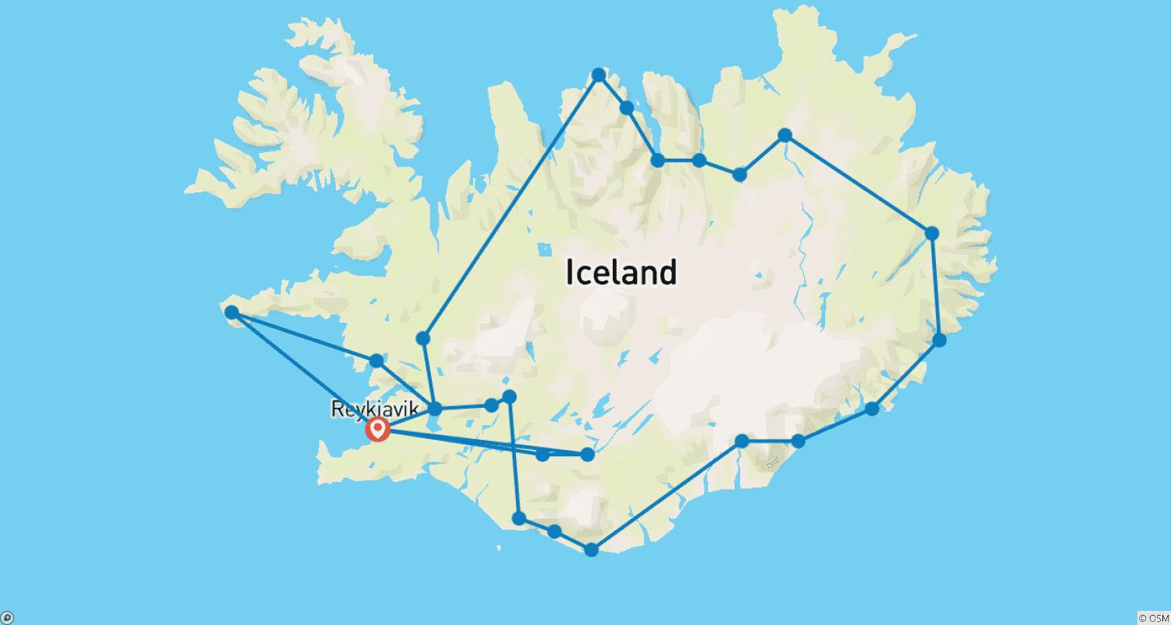

Tour ID: 132249  
Tour Name: Gems of Iceland with Northern Lights

Tour destinations: ['Reykjavik', 'Thingvellir National Park', 'Gullfoss', 'Kirkjubaejarklaustur', 'Skaftafell', 'Jokulsarlon', 'Reynisfjara', 'Skogafoss', 'Seljaland', 'Selfoss']

Tour destinations images:

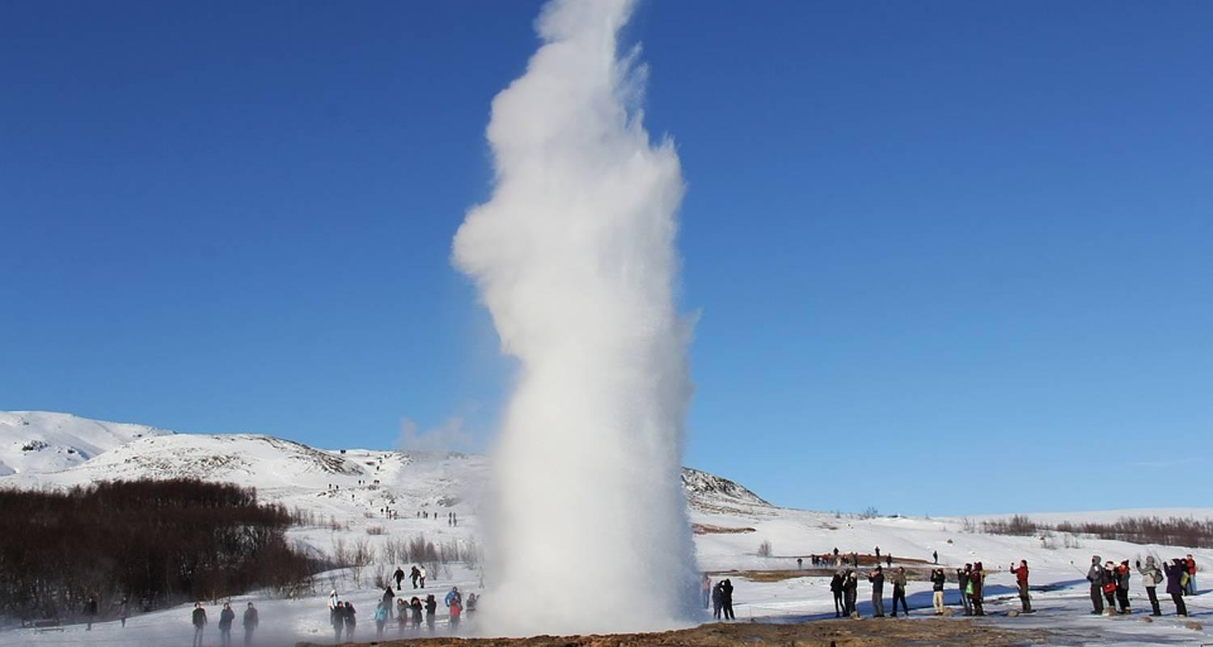

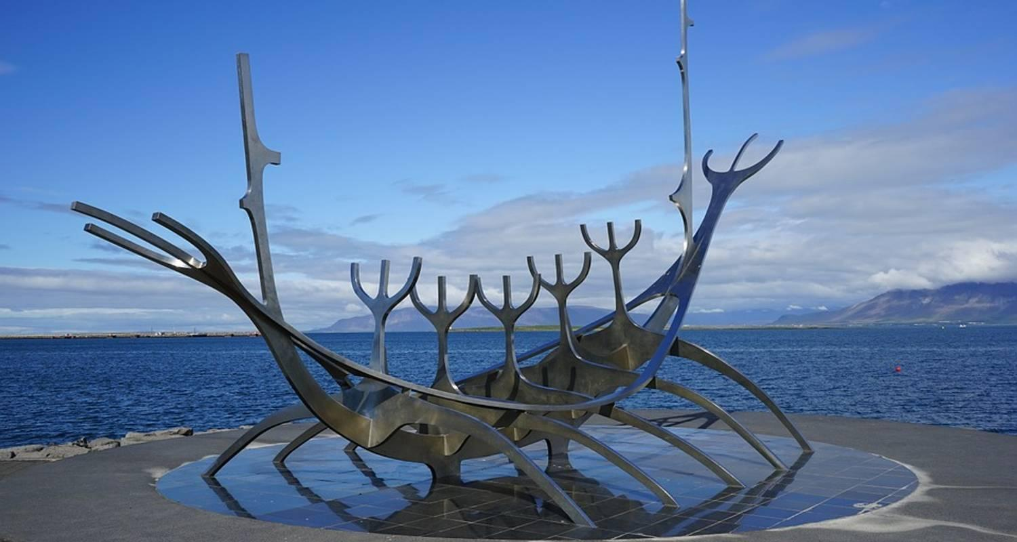

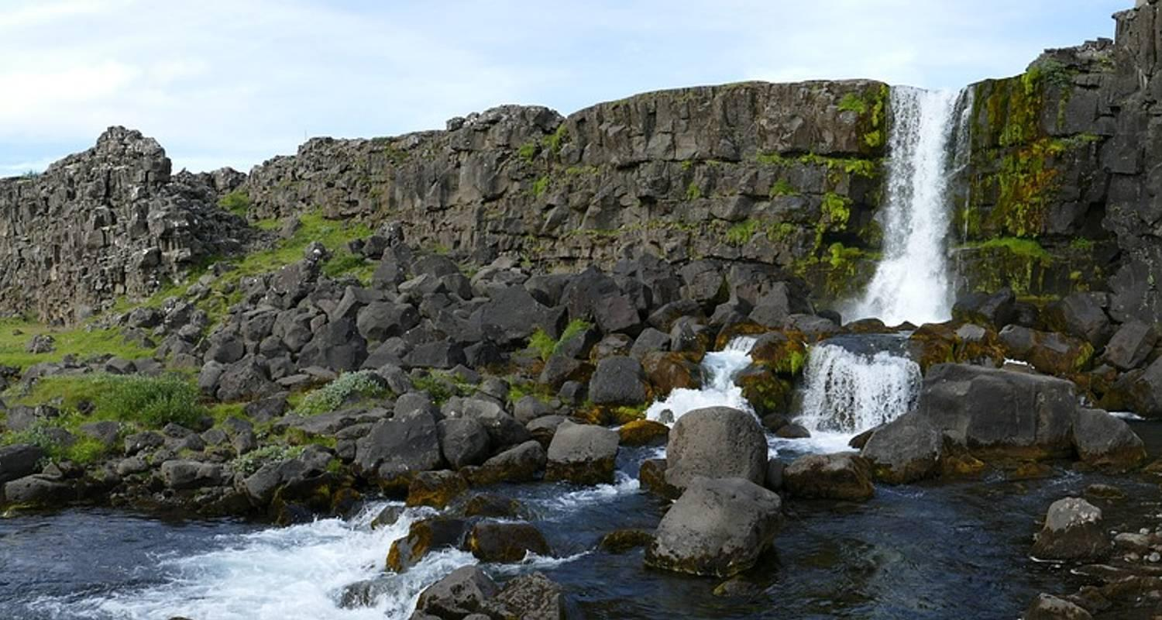

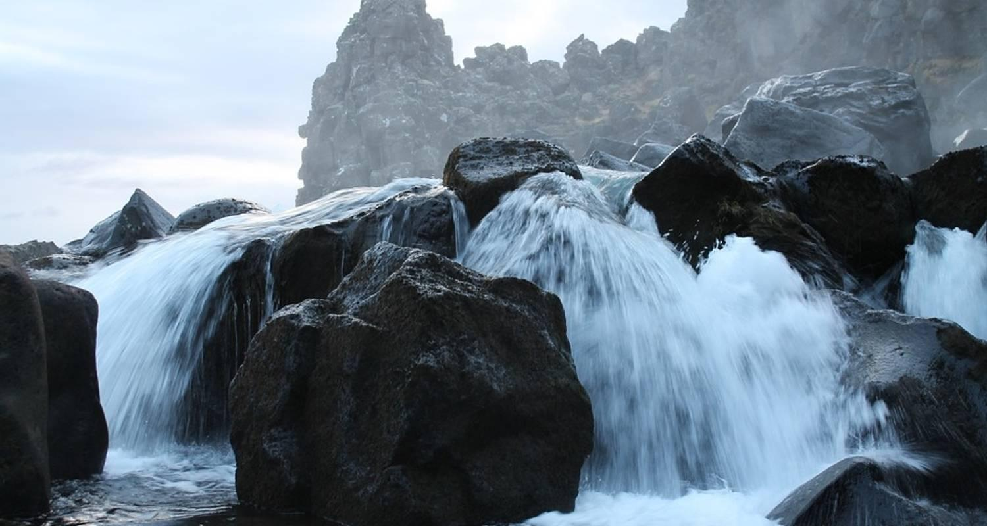

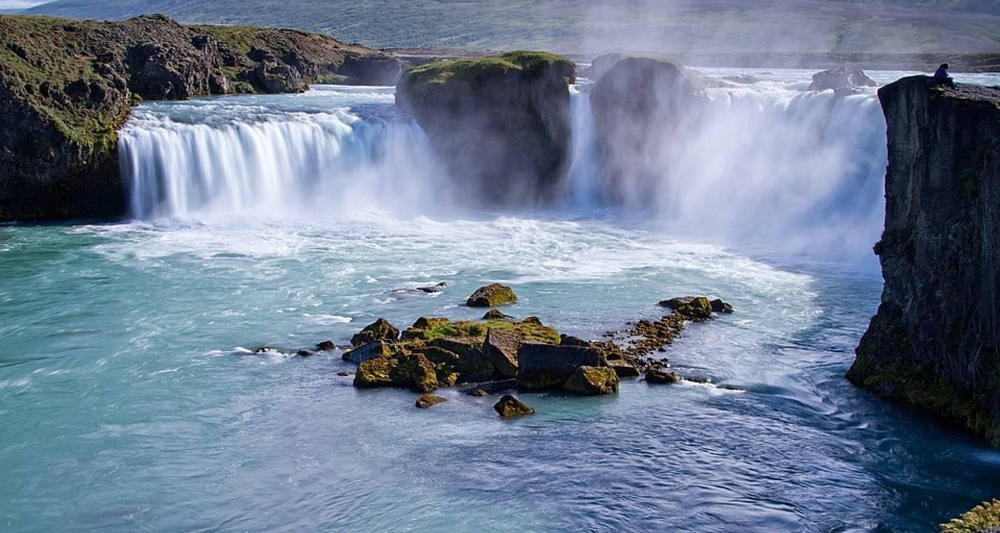

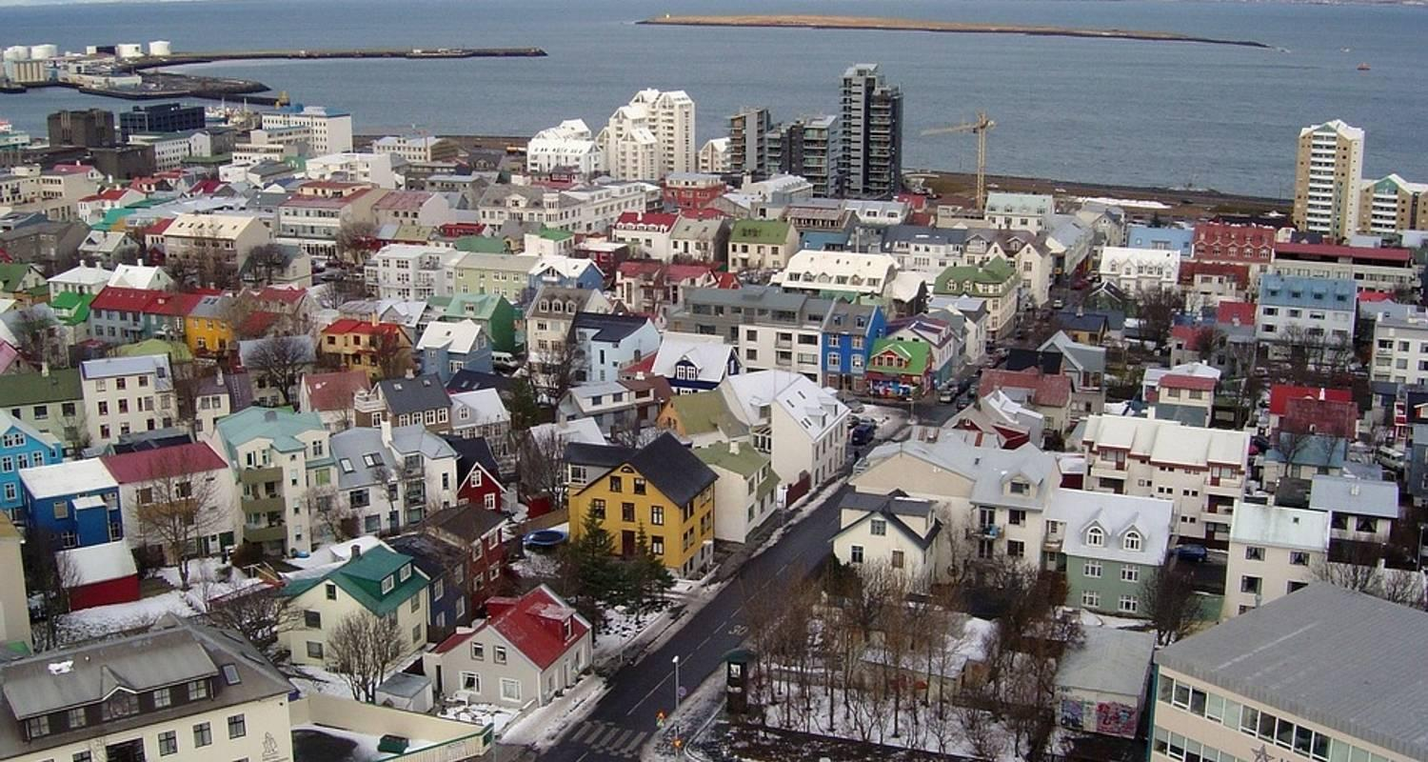

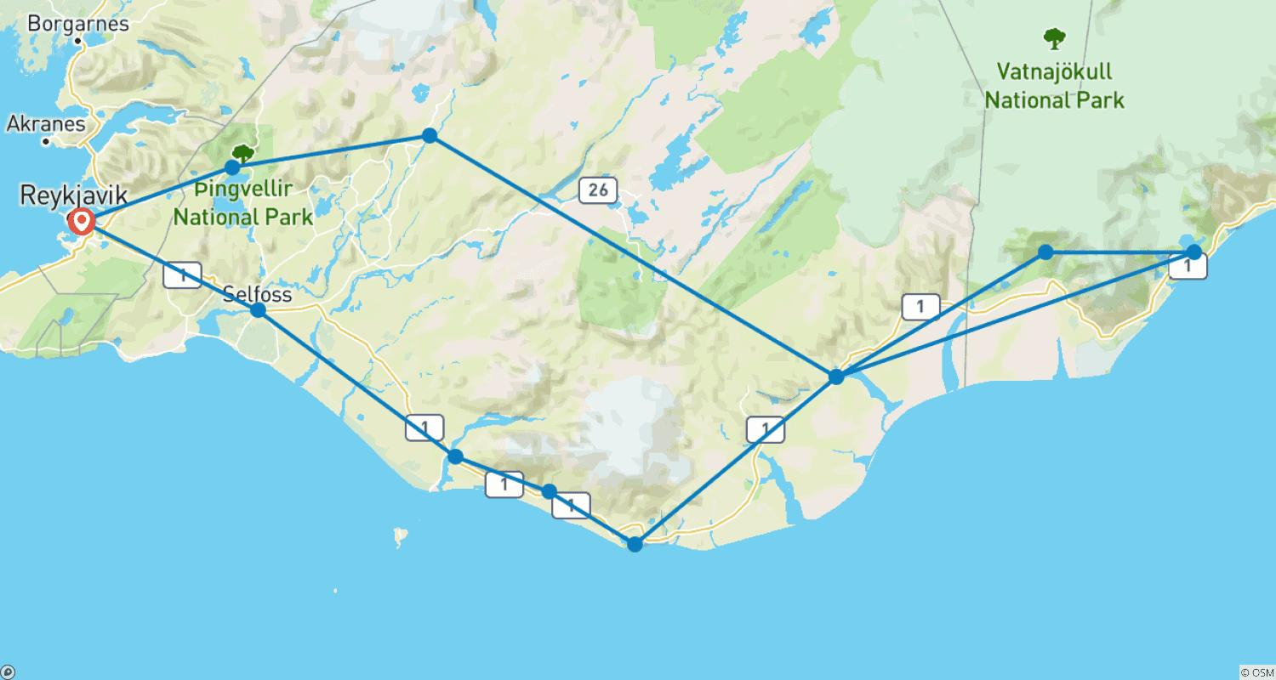

Tour ID: 134360  
Tour Name: Wellness Iceland

Tour destinations: ['Reykjavik', 'Hveragerdi']

Tour destinations images:

